Bansilal Ramnath Agarwal Charitable Trust’s

VISHWAKARMA INSTITUTE OF TECHNOLOGY, PUNE

(An Autonomous Institute, Affiliated to Savitribai Phule Pune University)



DEPARTMENT OF MECHANICAL ENGINEERING

**Academic Year 2020-21**

PROJECT REPORT

**ON**

“CLOUD BASED CONDITION MONITORING SYSTEM”

By

SHREYASH GUNWANT SABDE

M. TECH. (DESIGN ENGINEERING) ROLL NO:-13 GR.NO: 119M0025

Under the Guidance of

Prof. G. D. KORWAR

Bansilal Ramnath Agarwal Charitable Trust’s

VISHWAKARMA INSTITUTE OF TECHNOLOGY, PUNE

(An Autonomous Institute, Affiliated to Savitribai Phule Pune University)



DEPARTMENT OF MECHANICAL ENGINEERING

**Academic Year 2020-21.**

**CERTIFICATE**

This is to certify that the project titled **“CLOUD BASED CONDITION MONITORING SYSTEM”** has progressed well as per expectations at the end of first semester in the academic year 2019-2020 by **SHREYASH GUNWANT SABDE.** In partial fulfillment of the Requirement for the degree of Master of Technology in Mechanical Engineering with Specialization in Design Engineering as prescribed by the Savitribai Phule Pune University.

Prof. G. D. KORWAR Prof. (Dr.) M. B. Chaudhari Project Guide, Head of the Department,

Mechanical Engg. Department, Mechanical Engg. Department VIT, Pune VIT, Pune

Prof. (Dr.) R. M. Jalnekar Director, VIT, Pune

Bansilal Ramnath Agarwal Charitable Trust’s

**VISHWAKARMA INSTITUTE OF TECHNOLOGY, PUNE**

(An Autonomous Institute, Affiliated to Savitribai Phule Pune University)



DEPARTMENT OF MECHANICAL ENGINEERING

**Academic Year 2020-21**

CERTIFICATE OF EXAMINATION

This is to certify that the Project titled **“CLOUD BASED CONDITION MONITORING SYSTEM”** submitted by **SHREYASH GUNWANT SABDE, Registration No: 119M0025** is approved for mid-semester 4 of the Degree of Master of Technology in Mechanical Engineering with Specialization in Design Engineering under Savitribai Phule Pune University.

Date:

Place: Pune

|  |  |
| --- | --- |
| Internal Examiner Name:  Sign- | External Examiner Name:  Sign- |

# ACKNOWLEDGEMENT

It is matter of great pleasure for me to submit this project report on **“Cloud based condition monitoring system”** as a part of curriculum for Master’s Degree in Design Engineering of Mechanical Engineering as prescribed by the Savitribai Phule Pune University.

I am thankful to my project guide Prof. G. D. KORWAR for his constant encouragement and valuable guidance.

I am also thankful to Prof. (Dr.) M. B. CHAUDHARI of Mechanical Engineering Department for his valuable support.

I am also thankful to Prof. (Dr.) N. V. SATPUTE of Mechanical Engineering Department of Vishwakarma University for his valuable guidance.

I take this opportunity to express my deep sense of gratitude towards those, who have helped me in various ways, for preparing my report. At the last but not least, I am thankful to my parents, who had encouraged & inspired me with their blessings.

Date: SHREYASH GUNWANT SABDE

ROLL NO:-13 GR.NO: 119M0025

# ABSTRACT

Mechanical equipments are widely used in various industrial applications. Generally working in severe conditions, mechanical equipments are subjected to progressive deterioration of their state. The mechanical failures account for more than 60% of breakdowns of the system. In which near about 90% of the failures occurs due to heavy vibrations which leads to fatigue. These failures leads to expensive maintenance requirements, thus motivating interest in on- line condition monitoring so that we can predict the failure well before and probable damage can be avoided. Vibration analysis is very important aspect when it comes to a failure of a machine.

In this project we are trying to develop a condition monitoring system for a machine using an accelerometer and a raspberry pi card. The time series data of machine containing reading of time vs amplitude of vibration taken with the help of ADXL345 accelerometer are stored on the raspberry pi card. The Fast Fourier Transform (FFT) analysis is carried out to give frequency vs amplitude data. This data will be used to predict failure of the machine if there is any change in the amplitude of a specific frequency. Various filters can be applied for noise reduction. In today’s world of internet, why go for on-site analysis. All the data including important parameters of vibration analysis can be uploaded to a cloud server so that the data can be accessed from anywhere. All the work is done in the python programming language.

# Table of Contents

ACKNOWLEDGEMENT 4

ABSTRACT 5

Table of Contents 6

List of Figures 8

List of Table 9

1 INTRODUCTION 8

1.1 Condition Monitoring 8

1.2 Vibration as a Diagnostic tool 11

1.2 Fast Fourier Transform 12

1.4 Advantages of Condition Monitoring System 16

2 LITERATURE SURVEY 17

2.1 Literature study 17

2.2 Market Survey 22

CONCEPT DEVELOPMENT 23

3 Problem Statement 23

4 Objectives 23

3.3 Main Highlights of the project 24

3.4 Motivation of the project 24

3.5 Probable Applications 25

5. METHODOLOGY 26

a. General Procedure 27

b. Flowchart of python programming 28

c. Block diagram of Condition Monitoring system 29

6. REQUIRED HARDWARE AND SOFTWARE 30

6.1 Hardware Part 30

6.1.1 Accelerometer (ADXL 345) 30

6.1.2 Raspberry pi Micro-computer (MODB-1GB) 31

6.1.4 Gyroscope meter (MPU6050) 32

6.1.5 Arduino 34

6.1.6 Current sensor ACS712 35

6.1.7 Python Programming Language 36

6.1.8 Online Server (Cloud Storage) 37

6.1.9 Filter 38

6.1.10 Connecting cables, Jumper wires, charging adapter, Monitor, keyboard, mouse etc. 39

6.1.11 Installation of Hardware and Software 39

6.2 Coding Part 40

6.2.1 Code for extracting time domain data from sensor 40

6.2.2 Code for finding acceleration peaks 41

6.2.3 Code for Fast Fourier Transform 41

6.2.4 Code for pre-conditioning and uploading of data 42

6.2.5 Code for plotting the FFT graphs 43

6.2.6 Code for peak detection 43

6.2.7 Code for uploading data to drive 44

6.2.8 Code for automation of all the python codes 45

7 Experimentation 46

Setup 46

Raspberry Pi setup 50

8. RESULT & DISCUSSION 54

9. Conclusion 63

10 Future Work 64

11 REFERENCES 65

# List of Figures

Figure 1 Cost to failure analysis of Maintenance types 9

Figure 2 Evolution of Predictive Maintenance 9

Figure 3 Overall architecture of condition monitoring 10

Figure 4 Application of condition monitoring 10

Figure 5 Graph of FFT 12

Figure 6 Data conversion by FFT 13

Figure 7 the Spectrum 13

Figure 8 FFT graph when machine is working properly (blue) and not working properly (orange) 14

Figure 9 Vibration nature when imbalance is present 14

Figure 10 Frequency nature when imbalance is present 15

Figure 11 Condition monitoring system by velocity measurement 22

Figure 12 Gearbox 25

Figure 13 Pump 25

Figure 14 Forging Press 25

Figure 15 Condition monitor example 26

Figure 16 Flowchart of python programming 28

Figure 17 Block diagram of Condition Monitoring system 29

Figure 18 Block diagram of ADXL345 30

Figure 19 ADXL345 accelerometer 30

Figure 20 Raspberry pi Micro-computer 31

Figure 21 Block diagram of Raspberry pi 31

Figure 22 Block diagram of Raspberry pi 31

Figure 23 Breadboard 32

Figure 24 Block diagram of MPU6050 33

Figure 25 Arduino Uno 35

Figure 26 Current sensor ACS712 35

Figure 27 Symbol of Python 36

Figure 28 Symbol of Google Drive 37

Figure 29 Graph of signal with filter 38

Figure 30 Code for extracting sensor data 40

Figure 31 Code for finding acceleration peaks 41

Figure 32 Code for Fast Fourier Transform 41

Figure 33 Code for extracting FFT values 42

Figure 34 Code for plotting FFT graphs 43

Figure 35 Code for the peak detection 44

Figure 36 Code of uploading the data Output 44

Figure 37 Code for automation all the codes 45

Figure 38 Schematic diagram of Data acquisition system 47

Figure 39 DEWE DAQ system 47

Figure 40 accelerometer 48

Figure 41 cam follower setup with accelerometer mounting 48

Figure 42 Digital laser Tachometer 49

Figure 43 GPIO pinout diagram 50

Figure 44 Connection of accelerometer ADXL345 with raspberry pi 50

Figure 45 Raspberry pi after full connections 51

Figure 46 Full setup with connections 51

Figure 47 Wiring of MPU6050 with raspberry pi 52

Figure 48 Breadboard with two sensors connected 52

Figure 49 the whole connection with two sensors 53

Figure 50 Wiring diagram of current sensor ACS712 53

Figure 51 Wiring of ACS712 to Arduino Uno 53

Figure 52 FFT plot sample 55

Figure 53 Snap of google drive after uploading the diagram 56

Figure 54 Output of Current sensor ACS 712 in Arduino IDE 58

Figure 55 Dewsoft readings speed 1 59

Figure 56 Pi readings speed 1 59

Figure 57 Dewsoft readings speed 2 60

Figure 58 Pi readings speed 2 60

Figure 59 Variation in FFT plot with speed 62

# List of Table

Table 1 Output of accelerometer data from sensor 52

Table 2 Acceleration peaks 52

Table 3 FFT values 53

Table 4 Peaks in FFT values 54

Table 5 Gyroscope data 55

Table 6 Peaks in gyroscopic values 55

# 1 INTRODUCTION

In the process of channeling energy into the job to be performed forces are generated which will excite the individual parts of the machine directly or via the structure. During operation, machine parts are subjected to fatigue, wear, deformation and foundation settlement. 90% of the machine failures occur due vibrations which leads to fatigue.

Vibration analysis is always an important aspect when it comes to a failure of a machine. Because, when fault begins to develop in the machine, some of the dynamic processes change in the system as well, thereby influencing various machine parameters like performance, noise, vibration, etc. Such changes can act as indicator for early prediction of the failure. If we can able to predict the failure of machine well before, then probable damage can be avoided.

### 1.1 Condition Monitoring

Condition monitoring (CM) is the process of monitoring a parameter of condition in machinery (vibration, temperature etc.), in order to identify a significant change which is indicative of a developing fault. Placing sensors on industrial equipment to monitor performance, identifying changes in different parameters, and determining if these changes signal a need for equipment maintenance. The use of condition monitoring allows maintenance to be scheduled, or other actions to be taken to prevent consequential damages and avoid its consequences. Condition monitoring has a unique benefit in that conditions that would shorten normal lifespan can be addressed before they develop into a major failure. Condition monitoring techniques are normally used on rotating equipment, auxiliary systems and other machinery (compressors, pumps, electric motors, internal combustion engines, presses, etc). Using a machine condition monitoring system, we can detect failure signs before repair is required, allowing for proper maintenance scheduling and shutdown. Vibrations are the first warning sign that a machine is prone to failure. This warning sign can provide g of lead time before the actual failure date. Monitoring this data with vibration analysis hardware and software helps you predict this failure early and schedule proper maintenance.

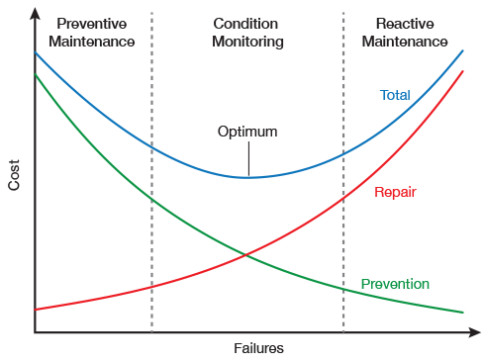

Figure 1 Cost to failure analysis of Maintenance types

The above graph helps us understand the advantage of condition monitoring in terms of the cost and failure. With the help of condition monitoring we can able to capture the optimum value between cost and failure. It will be very helpful in avoiding unnecessary maintenance, it saves the time and also the resources of the maintenance team. Also, with the help of condition monitoring we can schedule maintenance of machine at proper time which will reduce the loss time, idle time and production loss.

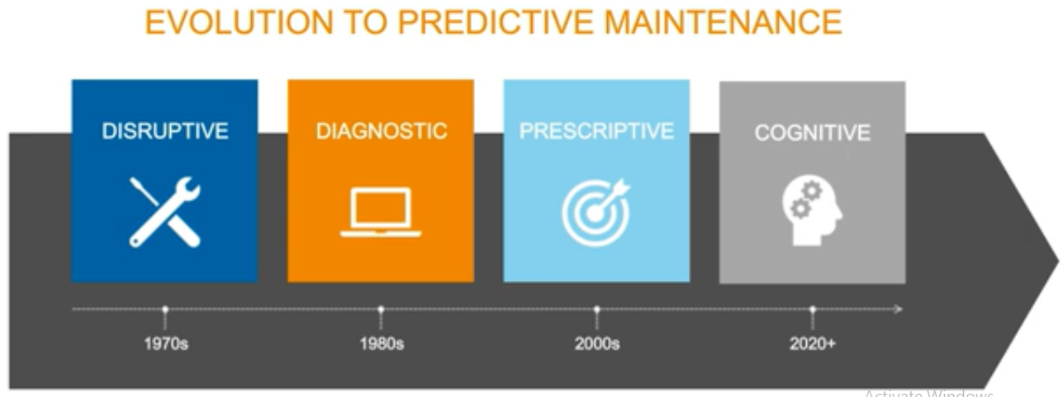

Figure 2 Evolution of Predictive Maintenance

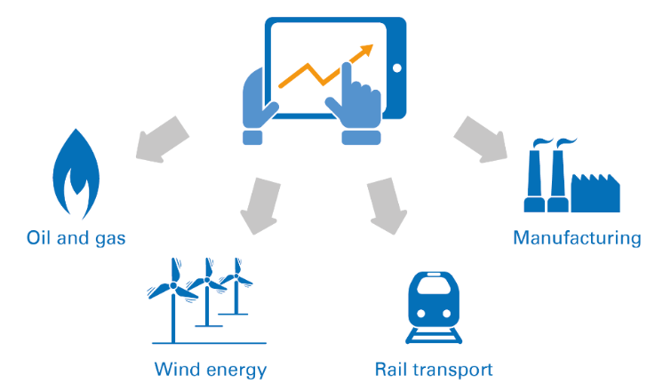

Figure 3 Overall architecture of condition monitoring

* Key Sensor Technologies for condition monitoring technologies

1) Vibration

2) Fluid Property

3) Pressure

4) Temperature

5) Humidity

6) Speed

7) Position

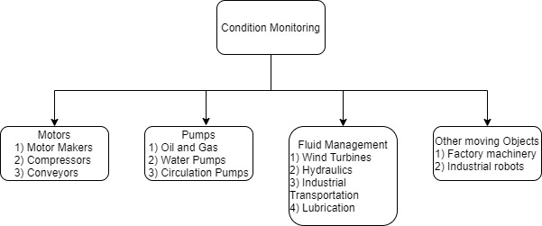

%3CmxGraphModel%3E%3Croot%3E%3CmxCell%20id%3D%220%22%2F%3E%3CmxCell%20id%3D%221%22%20parent%3D%220%22%2F%3E%3CmxCell%20id%3D%222%22%20value%3D%22Other%20moving%20Objects%26lt%3Bbr%26gt%3B%26lt%3Bdiv%20style%3D%26quot%3Btext-align%3A%20left%26quot%3B%26gt%3B%26lt%3Bspan%26gt%3B1)%20Factory%20machinery%26amp%3Bnbsp%3B%26lt%3B%2Fspan%26gt%3B%26lt%3B%2Fdiv%26gt%3B%26lt%3Bdiv%20style%3D%26quot%3Btext-align%3A%20left%26quot%3B%26gt%3B%26lt%3Bspan%26gt%3B2)%20Industrial%20robots%26lt%3B%2Fspan%26gt%3B%26lt%3B%2Fdiv%26gt%3B%22%20style%3D%22rounded%3D1%3BwhiteSpace%3Dwrap%3Bhtml%3D1%3B%22%20vertex%3D%221%22%20parent%3D%221%22%3E%3CmxGeometry%20x%3D%22560%22%20y%3D%22200%22%20width%3D%22120%22%20height%3D%2260%22%20as%3D%22geometry%22%2F%3E%3C%2FmxCell%3E%3CmxCell%20id%3D%223%22%20value%3D%22Fluid%20Management%26lt%3Bbr%26gt%3B%26lt%3Bdiv%20style%3D%26quot%3Btext-align%3A%20left%26quot%3B%26gt%3B%26lt%3Bspan%26gt%3B1)%20Wind%20Turbines%26amp%3Bnbsp%3B%26lt%3B%2Fspan%26gt%3B%26lt%3B%2Fdiv%26gt%3B%26lt%3Bdiv%20style%3D%26quot%3Btext-align%3A%20left%26quot%3B%26gt%3B%26lt%3Bspan%26gt%3B2)%20Hydraulics%26lt%3B%2Fspan%26gt%3B%26lt%3B%2Fdiv%26gt%3B%26lt%3Bdiv%20style%3D%26quot%3Btext-align%3A%20left%26quot%3B%26gt%3B%26lt%3Bspan%26gt%3B3)%20Industrial%20Transportation%26lt%3B%2Fspan%26gt%3B%26lt%3B%2Fdiv%26gt%3B%26lt%3Bdiv%20style%3D%26quot%3Btext-align%3A%20left%26quot%3B%26gt%3B%26lt%3Bspan%26gt%3B4)%20Lubrication%26amp%3Bnbsp%3B%26lt%3B%2Fspan%26gt%3B%26lt%3B%2Fdiv%26gt%3B%22%20style%3D%22rounded%3D1%3BwhiteSpace%3Dwrap%3Bhtml%3D1%3B%22%20vertex%3D%221%22%20parent%3D%221%22%3E%3CmxGeometry%

3BwhiteSpace%3Dwrap%3Bhtml%3D1%3B%22%20vertex%3D%221%22%20parent%3D%221%22%3E%3CmxGeometry%20x%3D%22320%22%20y%3D%2260%22%20width%3D%22120%22%20height%3D%2260%22%20as%3D%22geometry%22%2F%3E%3C%2FmxCell%3E%3C%2Froot%3E%3C%2FmxGraphModel%3E

Figure 4 Application of condition monitoring

`

### 1.2 Vibration as a Diagnostic tool

Diagnosis is the art of identifying machine condition from its signs or symptoms to determine its cause and effect. It is usually used for monitoring, detection and analysis of machine condition during an operation. Vibration signatures of the machine can offer an early warning to the operator for time based maintenance or to make a crucial decision before any serious problem or unscheduled downtime. The amplitude of the vibration signature gives an indication of the severity of the problem, whilst the frequency can indicate the source of the defect. It arises a need for developing a processing and analysis system of high level data to provide veracious extraction of data about the health of the machine. Various feature extraction techniques like statistical domain, frequency domain, time domain and time–frequency domain are used for obtaining diagnostic information.

Vibration analysis is a very powerful and reliable technique for monitoring the operating conditions of the machine. It is becoming more famous and familiar in industry due to non-destructive in nature and allows sustainable monitoring without any interfering in the process.

Vibration is oscillatory motion about a reference position and is caused by the transfer or storage of energy within structures, resulting from the action of one or more forces.

Vibrations can be categorized as

* + - Free vibrations : If no external force acts on a system and system is left to
    - Forced vibrations: a system is subjected to external force, (very common) Vibration Analysis (VA), applied in an industrial or maintenance environment aims to reduce maintenance costs and equipment downtime by detecting equipment faults. VA can use the units of Displacement, Velocity and Acceleration displayed as a time waveform (TWF), but most commonly the spectrum is used, derived from a fast Fourier transform of the TWF. The vibration spectrum provides important frequency information that can pinpoint the faulty component.

### Fast Fourier Transform

During the vibration transmissions, the vibration produced by a machine component consists of certain frequencies don’t change, although their levels may change from one location to another. Frequency analysis of the vibration signal is widely used to diagnose the machine faults. Fourier transform (FT), a frequency domain representation that estimates the strength of different frequency components (the power spectrum) of a time-domain signal. The forward FT is used to convert the signal from time to frequency domain, and an inverse FT is used to convert from frequency to time domain. FFT is considered as more effective and efficient diagnosis technique to obtain the Fourier Transform of discretized time signals. This signal is considered for a finite time called the ‘‘frame’’ or ‘‘time window’’, which is then digitized and stored for feature extraction. The selection of an appropriate sampling rate is important for signal digitization to avoid false frequency components that take place due to aliasing.

For converting a signal of the vibration acceleration from time domain into frequency domain the special algorithm was developed.

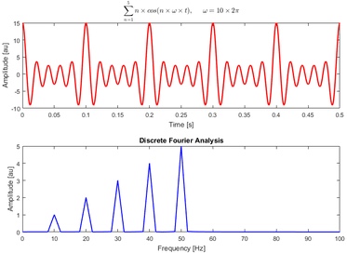

Figure 5 Graph of FFT

A fast Fourier transform (FFT) is an algorithm that computes the discrete Fourier transform (DFT) of a sequence, or its inverse (IDFT) at faster rate.

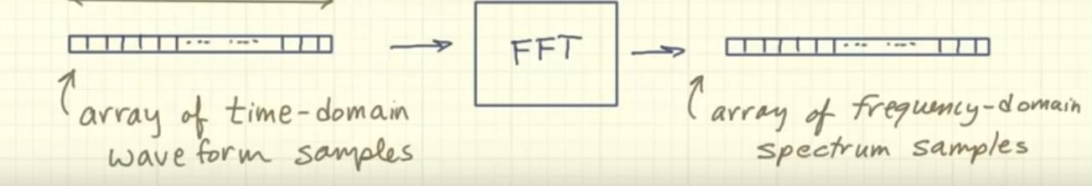

Figure 6 Data conversion by FFT

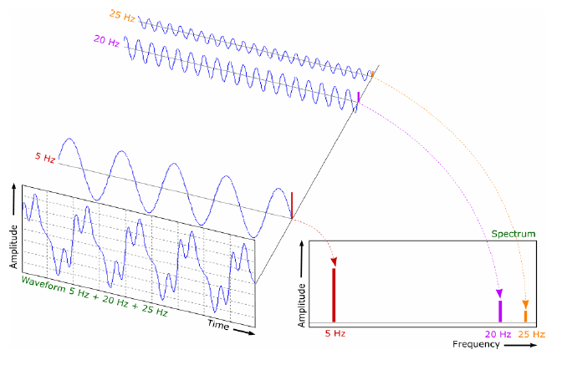

Figure 7 the Spectrum

Industrial Condition Monitoring Sensors

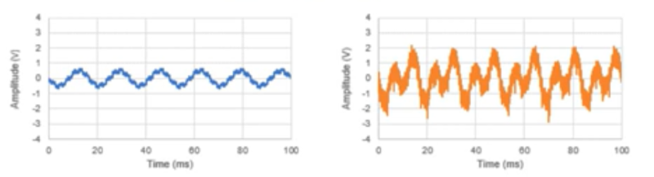

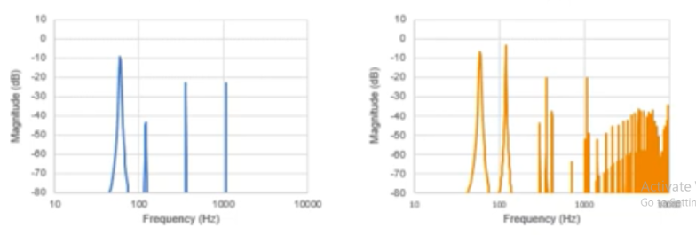

Figure 8 FFT graph when machine is working properly (blue) and not working properly (orange)

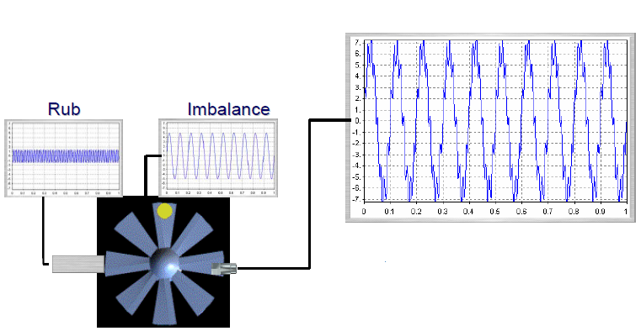

Figure 9 Vibration nature when imbalance is present

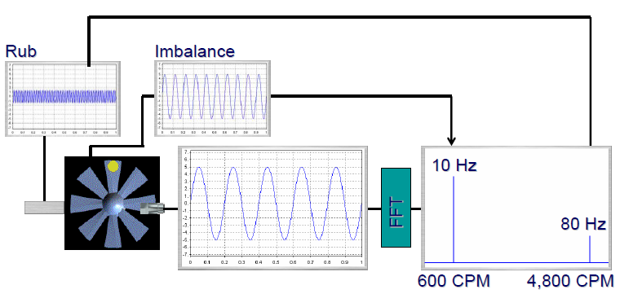

Figure 10 Frequency nature when imbalance is present

This frequency nature or spectrum tells us the presence of any imbalance and fault in machinery. This rise in vibration amplitude at other than natural frequency can be used as alert signal for maintenance team to look up to. We can compare the data or plot of vibration with vibration of new machines to see if any rise or change in vibration of nature.

### 1.4 Advantages of Condition Monitoring System

* Increased uptime and machine productivity
* Reduction of breakdowns / unplanned downtime, production losses and collateral damages
* Lower maintenance and spares inventory costs
* Enhanced human and environment safety
* Prioritizing Maintenance Tasks
* Increasing Lifespan of Machinery
* Ability to detect, locate and distinguish faults, in a non-destructive way by acquiring data during normal machinery operation as the Vibration Signature contains most information that can be applied to inaccessible components and used for on-line condition monitoring.
* Progress in development of vibration monitoring equipment enables implementation in on-line mode at acceptable cost where integrated hardware and software measures machinery performance 24/7 on-line in real time.
* Condition Monitoring permits efficient maintenance with a minimum of maintenance cost and minimum of unscheduled production stops.
* Generally, the off-line implementation is selected due to plant layout logistics against the cost of installing and maintaining an on-line system.
* On-line diagnostic system with continuous measurements is a choice for diagnostic of strategic high value machinery.

# 2 LITERATURE SURVEY

### 2.1 Literature study

In the previous chapter, we have discussed the basics of condition monitoring and its advantages, vibration analysis and FFT. In this chapter different on-going research and challenges have been addressed.

Many researchers performed different experiment on condition monitoring and many applied it to different applications in this field. Some of these applications are discussed as follows:

Development of Vibration Spectrum Analyzer Using the Raspberry Pi

By MarekIwaniec, Andriy Holovatyy, Vasyl Teslyuk, Mykhaylo Lobur, Kostyantyn Kolesnyk, Marta Mashevska

In the paper, the spectrum analyzer of vibration accelerations using the Raspberry Pi microcomputer and 3-axis digital MEMS ADXL345 accelerometer has been developed. The system includes accelerometer driver for Raspberry Pi, software for data acquiring and processing from the acceleration sensor, conversion of the vibration acceleration signals from time domain into frequency domain using DFT, graph plotting of the vibration accelerations and their spectra.

Recent Progress on Mechanical Condition Monitoring and Fault diagnosis By Chenxing Shenga, Zhixiong Lia, Li Qinb, Zhiwei Guoa, Yuelei Zhanga

This paper discusses the most recent progress in the mechanical condition monitoring and fault diagnosis. Excellent work is introduced from the aspects of the fault mechanism research, signal processing and feature extraction, fault reasoning research and equipment development. An overview of some of the existing methods for signal processing and feature extraction is presented. The advantages and disadvantages of these techniques are discussed. The review result suggests that the intelligent information fusion based mechanical fault diagnosis expert system with self-learning and self-updating abilities is the future research trend for the condition monitoring fault diagnosis of mechanical equipment.

Centrifugal Pump Condition Monitoring and Diagnosis Using Frequency Domain Analysis

By Maamar Ali Saud AL Tobi1 (&), Geraint Bevan2, Peter Wallace2, David Harrison2, and

K. P. Ramachandran

Centrifugal pumps are rotating machines which are widely used in process operations and other applications. Efﬁcient and failure-free operation of these pumps is important for effective plant operation and productivity. How- ever, the complexity of pumps, combined with continuous operation, can lead to failure and expensive maintenance requirements, thus motivating interest in on- line condition monitoring. This work investigates the application of frequency- domain analysis for classiﬁcation of various centrifugal pump conditions. Seven conditions are considered, namely, healthy (non-faulty); ﬁve mechanical faults: misalignment, imbalance, faulty bearing, faulty impeller and mechanical looseness; and a hydraulic fault: cavitation. A centrifugal pump test rig was built speciﬁcally for this research to simulate each fault condition and acquire the resulting vibration measurements. Signals are acquired from the pump using an accelerometer which is mounted on its bearing housing, and a data acquisition device (DAQ) is used to acquire the signals. Fast Fourier Transform (FFT) is used to identify which types of faults generate stationary or non-stationary signals. However, the accuracy of detection for the non-stationary signals is shown to require further improvement, and alternate methods are suggested accordingly.

Condition Monitoring of Deep Groove Ball Bearing using FFT Analyzer

By Vikram Talekar1, Prof. L. S. Dhamande2

Rolling element bearings are one of the major machinery components used in industries like power plants, chemical plants and automotive industries that require precise and efficient performance .Bearing failure occurs due to heavy dynamic loads and also contacts forces which exist between the bearing components, study of vibrations plays an important role in condition monitoring of the ball bearing/machinery. Unfortunately we cannot observe that defects by naked eyes in initial stage of failure. But when these faults are increased to large amount, they will leads to severe damage so it is very necessary to detect faults in bearing at an earlier stage. FFT analyzer can helps to detects in various components without disturbing setting of that component. Condition monitoring of bearings is important to avoid severe failures. Vibration analysis gets much advantage in factories as a predictive maintenance technique. In presented paper vibration response of non-defective bearing has taken and then purposefully various defects various component of bearings have made. It shows that every defect excites the system at its characteristic frequency. The location of the faults is indicated by the FFT Frequency domain spectrum. Also Signature analysis of bearing to observe unbalance, misalignment with increase in speed has done.

By Saubanov Oscar, Valeev Anvar

Maintenance and repair of pumping units requires a lot of high material costs and time. Planned maintenance is usually used now. But in inter-maintenance period nobody knows real technical condition of units. Automated control system of vibration parameters in real time is presented. It show actual state of a pump at every time moment. Developed by the authors diagnostic system includes a complex diagnosis of the spectral characteristics of the unit and trend analysis change of the vibration characteristics in real time. Comparison of current vibration spectrum with typical vibration spectrum of defects allows to identify a defect with a certain probability. Therefore, control of vibration and parametric characteristics of pumping units in real time allows to identify defect of pumping units at an early stage.

Real Time Machine Health Monitoring and Vibrational Analysis using FFT Approach

By Himanshu K. Patel, Dhagash Shah, Avani Raghuwanshi

This paper overviews the generalized health monitoring concept for machines and presents the health monitoring of a rotating machine based on Vibration Data Analysis using an enhanced Fast Fourier Transform Approach. Considering the importance of recent trends of the Industrial Internet of Things (IIoT), remote data analysis is implemented using Python, TCP/IP protocol and Hercules server terminal.

Fault diagnosis system of rotating machinery vibration signal By Lei Youa, Jun Huc, Fang Fanga, and Lintao Duanb

This paper designs a new type of fault diagnosis system of rotating machinery vibration signal, which can measure the vibration acceleration and velocity signals accurately, and analyze the vibration severity and frequency division amplitude spectrum of vibration signal. Experiment showed that our system can diagnose typical mechanical fault.

Gear Fault Detection Using Vibration Analysis and Continuous Wavelet Transform

By K. Vernekar, H. Kumar, and K. V. Gangadharan

Gears are the one of the most important machine components and widely used in transmission desing of automobiles and other rotating machinery. In industry, breakdown of such crucial compoenents causes heavy losses. This paper presents two signal processing techniques used for the fault detection of a gear used in internal combustion engine, they are conventional vibration spectrum analysis and continous wavelet transform. A fault diagnosis engine test setup is built for experimental studies to acquire vibration signal from a halthy and as well as simulated faulty gear. The vibration signal are acquired from internal combustion engine using accelerometer, under halthy and as well as simulated faulty gear conditions. This paper represents application of the conventional vibration sprectrum analysis and Morlet wavelet as a continous wavelet transform is used for the fault diagnosis of the gear.

Multiple-Fault Detection Methodology Based on Vibration and Current Analysis Applied to Bearings in Induction Motors and Gearboxes on the Kinematic Chain

By J. J. Saucedo-Dorantes, M. Delgado-Prieto, J. A. Ortega-Redondo, R. A. Osornio-Rios, and R. D. J. Romero-Troncoso

Gearboxes and induction motors are important components in industrial applications and their monitoring condition is critical in the industrial sector so as to reduce costs and maintenance downtimes. There are several techniques associated with the fault diagnosis in rotating machinery; however, vibration and stator currents analysis are commonly used due to their proven reliability. Indeed, vibration and current analysis provide fault condition information by means of the fault-related spectral component identification. This work presents a methodology based on vibration and current analysis for the diagnosis of wear in a gearbox and the detection of bearing defect in an induction motor both linked to the same kinematic chain; besides, the location of the fault-related components for analysis is supported by the corresponding theoretical models. The theoretical models are based on calculation of characteristic gearbox and bearings fault frequencies, in order to locate the spectral components of the faults. In this work, the influence of vibrations over the system is observed by performing motor current signal analysis to detect the presence of faults. The obtained results show the feasibility of detecting multiple faults in a kinematic chain, making the proposed methodology suitable to be used in the application of industrial machinery diagnosis.

Vibration condition monitoring of planetary gearbox under varying external load

W.Bartelmus, R.Zimroz

It is found that a planetary gearbox in bad condition is more susceptible to load than a gearbox in good condition. The estimated load time traces obtained by a demodulation process of the vibration acceleration signal for a planetary gearbox in good and bad conditions are given. It has been found that the most important factor of the proper planetary gearbox condition is connected with perturbation of arm rotation, where an arm rotation gives rise to a specific vibration signal whose properties are depicted by a short-time Fourier transform (STFT) and Wigner-Ville distribution presented as a time–frequency map. The paper gives evidence that there are two dominant low-frequency causes that influence vibration signal modulation, i.e. the varying load, which comes from the nature of the bucket wheel digging process, and the arm/carrier rotation. These two causes determine the condition of the planetary gearboxes considered. Typical local faults such as cracking or breakage of a gear tooth, or local faults in rolling element bearings, have not been found in the cases considered. In real practice, local faults of planetary gearboxes have not occurred, but heavy destruction of planetary gearboxes have been noticed, which are caused by a prolonged run of a planetary gearbox at the condition of the arm run perturbation. It may be stated that the paper gives a new approach to the condition monitoring of planetary gearboxes. It has been shown that only a root cause analysis based on factors having an influence on the vibration solves the problem of planetary gearbox condition monitoring.

The Vibration Monitoring Methods and Signal Processing Techniques for Structural Health Monitoring: A Review

Machines without vibrations in the working environment are something non-existent. During machining operations, these vibrations are directly linked to problems in systems having rotating or reciprocating parts, such as bearings, engines, gear boxes, shafts, turbines and motors. Vibration analysis has proved to be a measure for any cause of inaccuracy in manufacturing processes and components or any maintenance decisions related to the machine. The non-contact measurement of vibration signal is very important for reliable structural health monitoring for quality assurance, optimizing profitability of products and services, to enhance manufacturing productivity and to reduce regular periodic inspections. This paper presents a state-of-the-art review of recent vibration monitoring methods and signal processing techniques for structural health monitoring in manufacturing operations. These methods and techniques are used as a tool to acquire, visualize and analyze the sampled data collected in any machining operation which can then be used for decision making about maintenance strategies.

### 2.2 Market Survey

* + - Commonly available equipment measures the vibrations and report it.
    - There is no relationship established to locate the cause for further care.
    - Typically logic based on velocity measurement

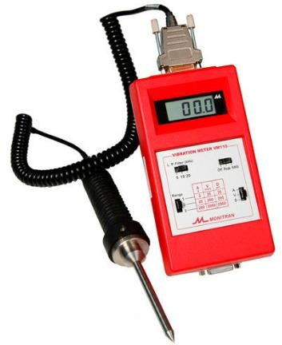

Figure 11 Condition monitoring system by velocity measurement

* + - Current vibration monitoring device available in market only give value of velocity and displacement.
    - One cannot predict cause of vibration from above values.
    - For prediction of cause, we need frequency of vibration for which the amplitude is raised.
    - So it is difficult to find and repair the fault with current system.
    - Also it has higher fault finding & maintenance time.

# CONCEPT DEVELOPMENT

In the previous chapter, the existing literature on FFT, Vibrations, sensors and analysis was presented. In this chapter, the details of the project such as problem statement, objectives, and main highlights are reported.

# 3 Problem Statement

To develop a cloud/ server based system which can be used to monitor health of the machines (viz. forging press, milling machine, gear box, etc) with the help of vibration analysis in order to predict failure so that the probable damage can be avoided.

# 4 Objectives

* + - Measure time domain data of machine vibrations with an accelerometer and Raspberry pi Hardware
    - Preconditioning of the time domain data to make it suitable for FFT/Wavelet analysis
    - Qualitative analysis of the time domain data (FFT/Wavelet) and extraction of frequency and magnitude parameters
    - Transmission of the parameters to remote server/cloud at regular intervals
    - Detection of change in vibration data so as to warn machine operator

### 3.3 Main Highlights of the project

1. Real time analysis of the machine-

This project lets you do real time analysis of the machine. Once you set-up all the hardware and software, the whole analysis requires only few minutes to give the result.

1. Localized analysis of sensor data-

The FFT analysis is carried out at the machine location itself, so no need to send raw data to somewhere and then importing the results.

1. Routine study of the machine data for a specific duration of time-

Routine study of the machine data helps to keep good health of the machine hence lowering the risk of the failure.

1. Predict failure of the machine by identification of change in sensor data-

Any change in the machine vibrations will be noticed and hence failure can be predicted

Monitor current state of machine from anywhere by enabling wireless transmission- By uploading vibration data to a cloud server, one can access it from anywhere on the globe. No need to be present at the machine location every time.

### 3.4 Motivation of the project

If we go for the vibration monitoring by traditional way, we are going to need FFT channel, accelerometer, FFT supporting computer software. Overall cost of this setup will be in lakhs. Also, portability restrictions are there. So, the overall setup is costly and to handle setup and software we need the skilled person. So, human dependency is there.

In this project we are proposing the low cost system that will be able to detect the change in vibration amplitude of machine and detect the corresponding frequency to tell the maintenance team on regular interval. So, they can predict the fault and schedule the maintenance accordingly.

### 3.5 Probable Applications

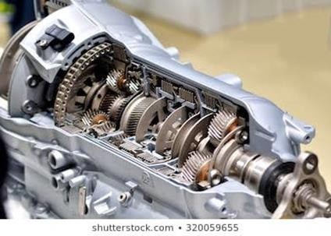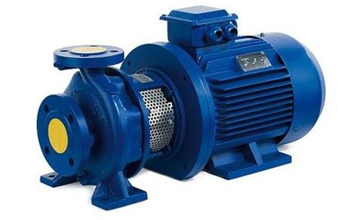

Figure 12 Gearbox

Figure 13 Pump

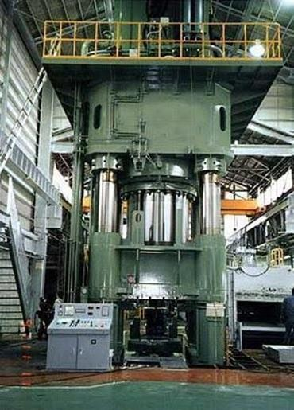

Figure 14 Forging Press

# METHODOLOGY

How do we monitor vibration?

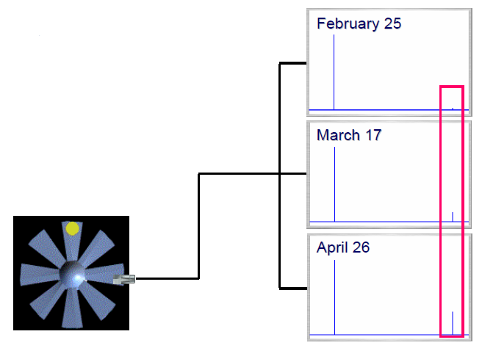

Figure 15 Condition monitor example

* In practice, we watch how the patterns and levels change over time.
* We relate the changes to what we know about the machine.
* The sensor converts the vibration into an electronic signal.
* The most common sensor is an accelerometer.
* The sensor is commonly attached using a magnet.
* Proper mounting is very important.
* “Repeatability” is essential.

Repeatability: -

* Vibration changes when the speed and load change.
* The machine must operate in the same state during every test.
* Check the speed and load with each measurement.
* Tests are typically performed every 30 days.
* Test a machine at 2 or 3 bearings.
* Collect vertical, horizontal and axial data.

Look for patterns and changes.

* The vibration pattern is important.
* How the pattern changes is equally important.

### General Procedure

1. Generating time domain sensor data.-

With the help of accelerometer the machine vibration data will be collected. This data is in the time domain that is the data is in the form of time versus amplitude of acceleration. This data will be sent to raspberry pi microcomputer.

1. Qualitative Analysis of the data -

This mainly includes conversion of the data from time domain to frequency domain that is time versus amplitude to frequency versus amplitude. This is achieved by Fast Fourier Transform (FFT) analysis with the help of python programming language.

1. Finding peaks of the acceleration and FFT data -  
   Peaks are found from acceleration data and their corresponding time. So that, we can check if there is change in pattern or rise in peak value. Similarly we will find the peak in amplitude of vibration and their corresponding frequency.
2. Plotting the FFT graphs -  
   Then we plot the graphs of the FFT data in three axis, as data visualization gives us the good representation of the vibration nature. From graphs we can clearly visualize peaks in FFT graph. Also we save this plot in png format. We also save the top 5 peaks we are getting in acceleration value and FFT amplitude value in csv format.
3. Extracting and uploading the important parameters to the server -

Frequency and magnitude parameters are important in failure detection. The important frequencies and their respective amplitudes are uploaded to the cloud server. Along with the csv file containing peaks in acceleration data and fft amplitude. Also the plots we are uploading to cloud.

### Flowchart of python programming

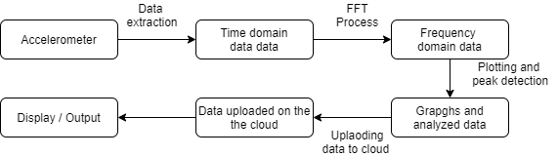

Figure 16 Flowchart of python programming

* First it start with connecting the accelerometer to pi through wiring and I2C settings. Then with the help of code we can extract data from sensor in time domain.
* That data is then processed through the FFT algorithm that will convert the time domain data to frequency domain data. This will give us the idea about the vibration nature of machine. Also idea about the frequency at which peak is occurring.
* Then this FFT data is plotted on the graph for better visualization of vibration nature. This can give idea about rise in amplitude of vibration.
* This FFT data is stored in csv file format with which we can find peaks in accelerometer and FFT data, also we can save the plot in png/jpeg format for further analysis purpose.
* All this files we save in the pi memory then we upload to the google drive, from where respective people can find this data and analyze the vibration nature of machine and then can decide about maintenance schedule.
* All this data is available to maintenance team. Which our raspberry pi system will send on periodic basis, which can be one hour, three hour, one day anything maintenance team want.
* Similarly, another machine can be monitored with same parameter or another parameter like gyroscope, temperature, current, etc. This can be achieved on same raspberry pi system with multiple sensor integration.

### Block diagram of Condition Monitoring system

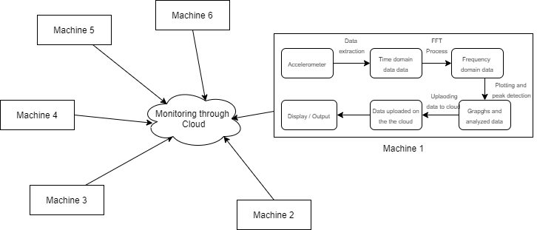

Figure 17 Block diagram of Condition Monitoring system

System we can explained in previous section is for one parameter and one machine.

Same raspberry pi setup can be used to monitor different parameters with the help of multiple sensor integration. Many parameters can be monitored at a time like gyroscope, temperature, current, etc.

The above the figure shows the complete diagram of condition monitoring. Which gives the idea that many parameters on many different machines can be monitored through condition monitoring.

In that way this system can be made centralized with which any machine can be monitored and that through cloud that means operator don’t have to go machine physically. All the machines that we want to monitor are connected to pi system that will send the monitoring report periodically to cloud from where respective teams can have access to reports to analyze the machine health or condition. All this can be achieved with proper sensors and condition monitoring system. Which in the result can reduce the breakdown time, increase the production capacity and also helps in planning preventive maintenance.

# 6. REQUIRED HARDWARE AND SOFTWARE

## 6.1 Hardware Part

### 6.1.1 Accelerometer (ADXL 345)

* + - The ADXL345 is a small, thin, ultralow power, 3-axis accelerometer with high resolution (13-bit) measurement at up to ±16 g.
    - Output data is formatted as 16-bit twos complement, accessible through either a SPI (3- or 4-wire) or I2C digital interface.

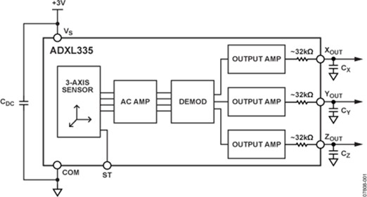

Figure 18 Block diagram of ADXL345

* + - Measures the static acceleration of gravity in tilt-sensing applications, as well as dynamic acceleration resulting from motion or shock. Its high resolution (3.9 mg/LSB) enables measurement of inclination changes less than 1.0°.
    - Several special sensing functions are provided. Activity and inactivity sensing detect the presence or lack of motion by comparing the acceleration on any axis with user- set thresholds.
    - An integrated memory management system with a 32-level first in, first out (FIFO) buffer can be used to store data to minimize host processor activity and lower overall system power consumption.
    - Low power modes enable intelligent motion-based power management with threshold sensing and active acceleration measurement at extremely low power dissipation.

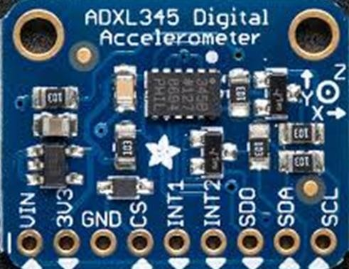

Figure 19 ADXL345 accelerometer

### 6.1.2 Raspberry pi Micro-computer (MODB-1GB)

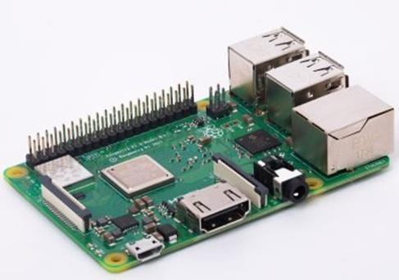

Figure 20 Raspberry pi Micro-computer

* + - The Raspberry Pi is a low cost, **credit-card sized computer** that plugs into a computer monitor or TV, and uses a standard keyboard and mouse. It’s capable of doing everything you’d expect a desktop computer to do, from browsing the internet and playing high-definition video, to making spreadsheets, word-processing, and playing games. It has the ability to interact with the outside world, and has been used in a wide array of digital maker projects.

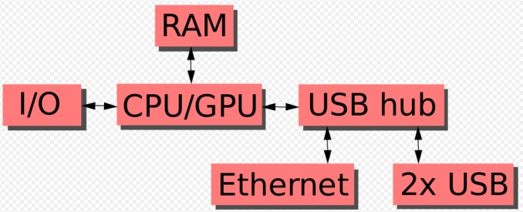

Figure 21 Block diagram of Raspberry pi

* + - The Raspberry Pi 3+ uses a Broadcom BCM2837B0 SoC with a 1.4 GHz 64-bit quad- core [ARM Cortex-A53](https://en.wikipedia.org/wiki/ARM_Cortex-A53) processor, with 512 KB shared L2 cache.

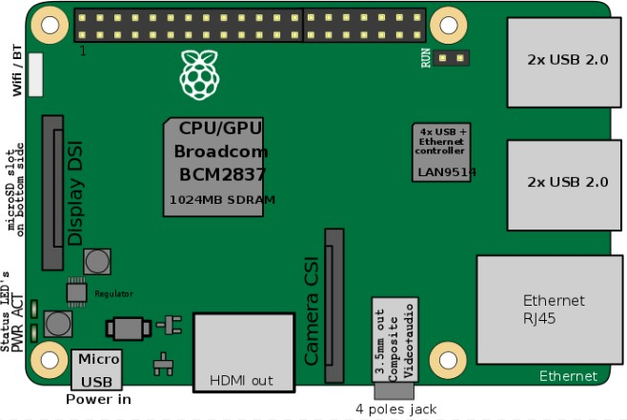

Figure 22 Block diagram of Raspberry pi

* + - For this project we using Raspberry Pi to store program for filter and FFT and process signal received from Accelerometer and convert into desire graph.

6.1.3 Breadboard: - A breadboard is a rectangular plastic board with a bunch of tiny holes in it. A breadboard is used to build and test circuits quickly before finalizing any circuit design. The breadboard has many holes into which circuit components like ICs and resistors can be inserted. In these tiny holes we can insert male side of jumper wire and other female side is connected with other jumper wire. This way we can connect many jumper wires we want in series or parallel way as per requirement. This is useful in way that we can connect more sensors to gpio of raspberry pi such as power pin of raspberry pi is need for every sensor we will be using. In this case breadboard helps in using multiple sensors on raspberry pi.

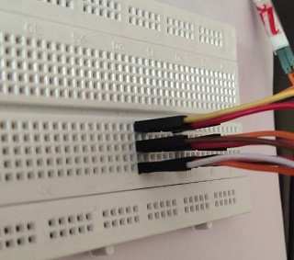

Figure 23 Breadboard

### 6.1.4 Gyroscope meter (MPU6050)

* + - The InvenSense MPU-6050 sensor contains a MEMS accelerometer and a MEMS gyro in a single chip.
    - It is very accurate, as it contains 16-bits analog to digital conversion hardware for each channel. Therefor it captures the x, y, and z channel at the same time. The sensor uses the I2C-bus to interface with the Arduino.
    - The MPU-6050 is not expensive, especially given the fact that it combines both an accelerometer and a gyro.
    - The MPU 6050 is a 6 DOF (Degrees of Freedom) or a six axis IMU sensor, which means that it gives six values as output. Three values from the accelerometer and three from the gyroscope. The MPU 6050 is a sensor based on MEMS (Micro Electro Mechanical Systems) technology.

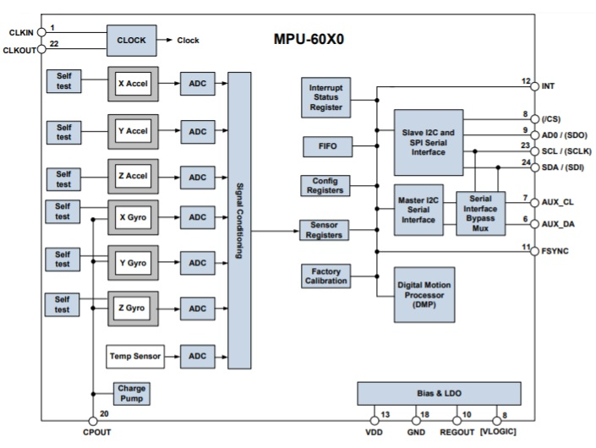

Figure 24 Block diagram of MPU6050

The gyroscope present in MPU6050 can detect rotation about the three axis X, Y, Z. Coriolis effect causes a vibration when the gyros are rotated about any of the axes. These vibrations are picked up by the capacitor. The signal produced is then amplified, demodulated and filtered to produce a voltage that is proportional to the angular rate. This voltage is then digitized using ADC’s.

Specifications: -

* MPU6050 has a 3-axis gyroscope, 3- axis Accelerometer and a Digital motion processor integrated on a single chip.
* It works on the power supply of 3V-5V.
* MPU6050 uses the I2C protocol for communication and transfer of data.
* This module has a built-in 16-bit ADC which provides great accuracy.
* MPU6050 can be interfaced with other IIC devices such as Magnetometers.
* MPU6050 also has an in-built temperature sensor.
* MPU6050 consists of three 16-bits ADC’s for digitizing the gyroscope outputs.

Applications of MPU6050: -

* For recognizing in-air gestures this module is used.
* For “no-touch” UI application control and navigation MPU6050 is used.
* In motion command technology for gesture short-cuts, this module is used.
* Due to its small size, this module is used in handsets and portable gaming equipment. Motion-based game controllers also have this module. 3D remote controllers, 3D mice also use this module.
* Wearables used for health, fitness and sports also containMPU6050.
* This module can also be found in many toys.
* For IMU measurements MPU6050 is used.
* In drones and quadcopters, MPU6050 is used for position control.
* This module has also found application in self-balancing robots. MPU6050 is highly preferred for robotic arm control.

### 6.1.5 Arduino

Arduino is an open-source electronics platform based on easy-to-use hardware and software. [Arduino boards](https://www.arduino.cc/en/Main/Products) are able to read inputs - light on a sensor, a finger on a button, and turn it into an output activating a motor, turning on an LED, publishing something online. You can tell your board what to do by sending a set of instructions to the microcontroller on the board. To do so you use the [Arduino programming language](https://www.arduino.cc/en/Reference/HomePage) (based on [Wiring](http://wiring.org.co/)), and [the Arduino Software (IDE)](https://www.arduino.cc/en/Main/Software), based on [Processing](https://processing.org/).

It’s simple and accessible user experience. The Arduino software is easy-to-use for beginners, yet flexible enough for advanced users. It runs on Mac, Windows, and Linux. Arduino also simplifies the process of working with microcontrollers. It offers some advantage for users as following

* Inexpensive
* Cross Platform
* Simple, clear programming environment
* Open source and extensible software

The flexibility of the Arduino board is enormous so that one can do anything they imagine. This board can be connected very easily to different modules such as obstacle sensors, presence detectors, fire sensors, GSM Modules GPS modules, etc. The main function of the Arduino board is to control electronics through reading inputs & changing it into outputs because this board works like a tool.

There are many types Of Arduino boards like Arduino Uno (R3), Arduino Nano, Arduino Micro, Arduino Due, Arduino Bluetooth, Arduino Mega (R3) Board, Arduino Leonardo Board, Arduino Robot, Arduino Pro Mic, Arduino Ethernet, Arduino Zero, and Fastest Arduino Board.

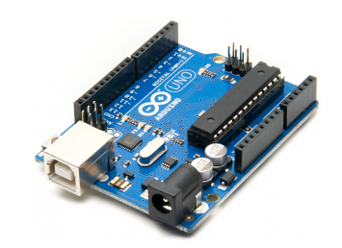

Figure 25 Arduino Uno

This Arduino hardware is utilized only for making user of current sensor, which works well easily and connects well with Arduino than raspberry pi. Later Arduino is connected with raspberry pi to get the data from Arduino.

### 6.1.6 Current sensor ACS712

The ACS712 is a fully integrated, hall effect-based linear current sensor with 2.1kVRMS voltage isolation and a integrated low-resistance current conductor. Technical terms aside, it's simply put forth as a current sensor that uses its conductor to calculate and measure the amount of current applied. The ACS712 measures current in two directions. It means that if we sample fast enough and long enough, we sure to find the peak in one direction and the peak in another direction as the ACS712 have 5 μs output rise time in response to step input current.

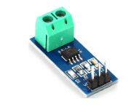

Figure 26 Current sensor ACS712

Features and Benefits

* Low-noise analog signal path
* Device bandwidth is set via the new FILTER pin
* 5 μs output rise time in response to step input current
* 80 kHz bandwidth
* Total output error 1.5% at TA = 25°C
* Small footprint, low-profile SOIC8 package
* 1.2 mΩ internal conductor resistance
* 2.1 kVRMS minimum isolation voltage from pins 1-4 to pins 5-8
* 5.0 V, single supply operation
* 66 to 185 mV/A output sensitivity
* Output voltage proportional to AC or DC currents
* Factory-trimmed for accuracy
* Extremely stable output offset voltage
* Nearly zero magnetic hysteresis
* Ratio metric output from supply voltage

### 6.1.7 Python Programming Language



Figure 27 Symbol of Python

**Python** is an interpreted, high-level, general-purpose programming language. Created by Guido van Rossum and first released in 1991, Python's design philosophy emphasizes code readability with its notable use of significant whitespace. Its language constructs and object- oriented approach aim to help programmers write clear, logical code for small and large-scale projects.

Python is dynamically typed and garbage-collected. It supports multiple programming paradigms, including procedural, object-oriented, and functional programming. Python is often described as a "batteries included" language due to its comprehensive standard library.

Python was conceived in the late 1980s as a successor to the ABC language. Python 2.0, released in 2000, introduced features like list comprehensions and a garbage collection system capable of collecting reference cycles. Python 3.0, released in 2008, was a major revision of the language that is not completely backward-compatible, and much Python 2 code does not run unmodified on Python 3.

### 6.1.8 Online Server (Cloud Storage)

Cloud storage is a model of computer data storage in which the digital data is stored in logical pools. The physical storage spans multiple servers (sometimes in multiple locations), and the physical environment is typically owned and managed by a hosting company. These cloud storage providers are responsible for keeping the data available and accessible, and the physical environment protected and running. People and organizations buy or lease storage capacity from the providers to store user, organization, or application data.



Figure 28 Symbol of Google Drive

Cloud storage services may be accessed through a collocated cloud computing service, a web service application programming interface (API) or by applications that utilize the API, such as cloud desktop storage, a cloud storage gateway or Web-based content management systems.

### 6.1.9 Filter

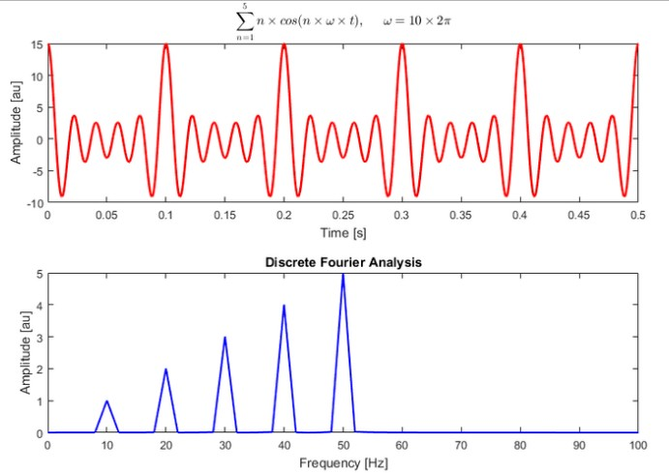

Figure 29 Graph of signal with filter

* + - In signal processing, a **filter** is a device or process that removes some unwanted components or features from a signal.
    - Filtering is a class of signal processing, the defining feature of filters being the complete or partial suppression of some aspect of the signal.
    - Most often, this means removing some frequencies or frequency bands. However, filters do not exclusively act in the frequency domain; especially in the field of image processing many other targets for filtering exist.
    - Correlations can be removed for certain frequency components and not for others without having to act in the frequency domain.
    - To digitally analyze and manipulate an analog signal, it must be digitized with an analog-to-digital converter (ADC). Sampling is usually carried out in two stages, discretization and quantization. Discretization means that the signal is divided into equal intervals of time, and each interval is represented by a single measurement of amplitude. Quantization means each amplitude measurement is approximated by a value from a finite set.

### 6.1.10 Connecting cables, Jumper wires, charging adapter, Monitor, keyboard, mouse etc.

* Connecting cables needed like HDMI cable to connect monitor to raspberry pi card
* Jumper wires connects accelerometer to the raspberry pi card
* Charging adapter for power supply to raspberry pi card
* Monitor screen displays output of a program
* Keyboard, mouse is to give inputs

### 6.1.11 Installation of Hardware and Software

To run the whole setup we need to fix the accelerometer on the machine then it is connected to raspberry pi card.

A 5 watt USB charger gives power to raspberry pi.

Monitor screen is connected to raspberry pi card through HDMI cable

Keyboard, mouse are connected to raspberry pi through USB ports provided on raspberry pi.

Then python programming language is installed on the raspberry pi card to run the python codes.

## 6.2 Coding Part

Previous chapter focused on which software and hardware are required for the project. In this chapter, codes developed to extract data, process it and to analyze it are given with their outputs

### 6.2.1 Code for extracting time domain data from sensor

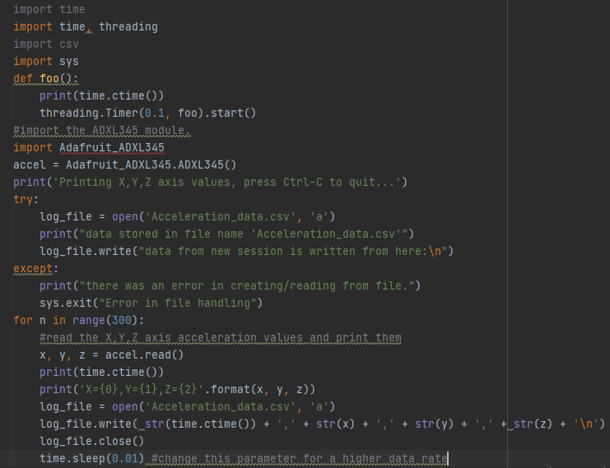

Figure 30 Code for extracting sensor data

We are using the accelerometer ADXL 345 sensor for data extraction, first we have installed Adafruit ADXL library. Then with the help of the above code we are recording accelerometer data with the time delay we want. And we save the data in csv file named ‘Acceleration_data.csv’.

### 6.2.2 Code for finding acceleration peaks

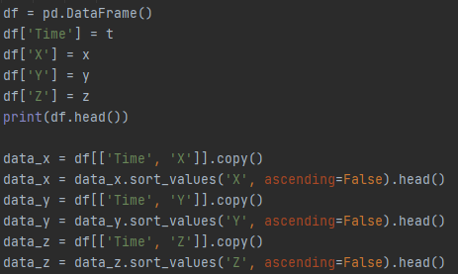

Figure 31 Code for finding acceleration peaks

The peak in the acceleration values are find with the help of sorting command. We created separate data frame to perform the sorting operation. Pandas library is used here.

### 6.2.3 Code for Fast Fourier Transform

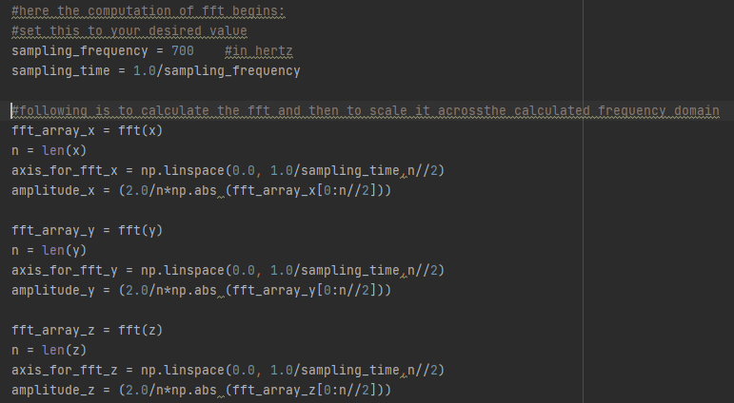

Figure 32 Code for Fast Fourier Transform

The above code use to convert time domain data into frequency domain data. For which we are calling the values in x, y, z direction and perform FFT algorithm on it. For which we are using the scipy.fftpack library, pandas, Numpy, Pandas libraries of python.

### 6.2.4 Code for pre-conditioning and uploading of data

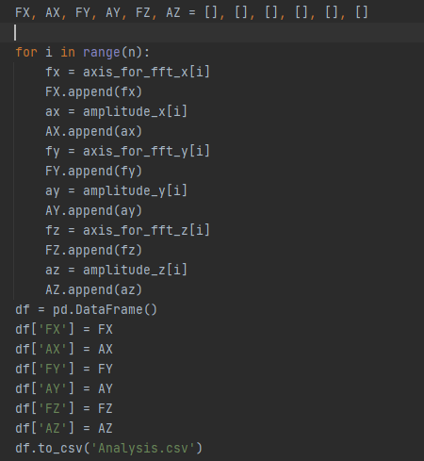

Figure 33 Code for extracting FFT values

This code is in continuation of the previous code. Previous one converts the time domain data into frequency domain data and this one saves this converted data in the format of csv file.

### 6.2.5 Code for plotting the FFT graphs

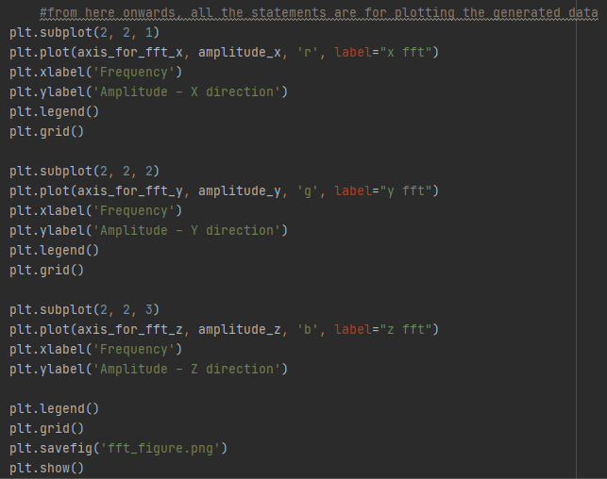

Figure 34 Code for plotting FFT graphs

Data visualization is the best representation of the data. It is easy and convenient to draw conclusion from data than tabular data.

So with the help of the code above shown we plot the fft graphs from the data we have. We plot and we save the fft figure for analysis purpose.

### 6.2.6 Code for peak detection

The peak in the acceleration values are find with the help of sorting command. We created separate data frame to perform the sorting operation. Pandas library is used here. In this code, we created three data frames each one representing frequency and amplitude of each axis. There, separate sorting performance is carried out and we in the last we combine or merge them in one.

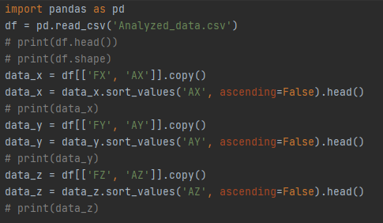

Figure 35 Code for the peak detection

### 6.2.7 Code for uploading data to drive

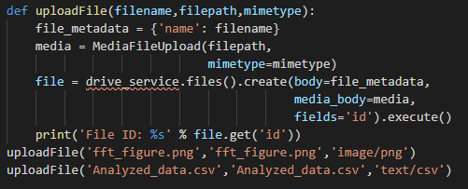

Figure 36 Code of uploading the data Output

For uploading the data to google cloud, we are first enabling the google api service in the cloud setting. Then with the help above function we upload the data to google drive. Where it can be stored and accessible even after long time.

### 6.2.8 Code for automation of all the python codes

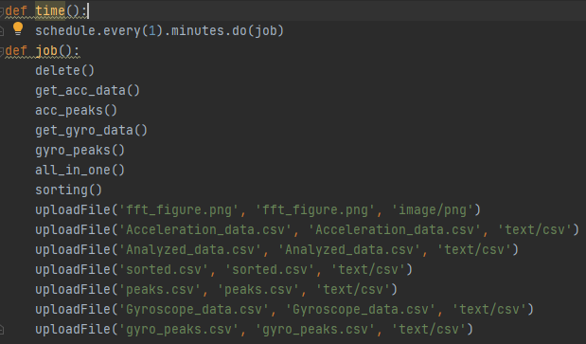

Figure 37 Code for automation all the codes

This code for the automation run all the codes automatically. This is achieved by schedule command. Here, we set the all the codes in order such that they run in order we set.

First, we are calling the get_data () function that will collect the acceleration values from test setup and save the acceleration values in csv file format.

Then the all_in_one () function perform the Fourier transformation, saves the FFT values in three axis in csv file format. This function also plots the FFT graph and saves it in png format.

Then the sorting is performed using the sorting operation by calling the acc_peaks() and sorting() functions gives the top 5 amplitude in acceleration values and FFT vibration amplitude in every axis respectively along with their corresponding frequency and saves in the csv file format.

And finally uploadFile() function uploads the required files to google drive.

We are uploading the acceleration values, FFT values, sorted FFT values and FFT figures to google drive for further analysis.

So, final output from this raspberry setup is pi is able to take the acceleration values after regular interval and then pi processor performs the FFT analysis and then the FFT values, top amplitudes and their corresponding frequencies and FFT plots are uploaded to google drive. From their google drive maintenance team can see the FFT values and plots to check if any change in vibration nature. So to take further actions accordingly.

# Experimentation

First of all we have finalized the steps we wanted to perform and created the python codes for our application. Each python code is tested on raw data to test if it performing well. To get the plots as we wanted and uploading the data on the google drive. Initially this setup is tested. The raspberry pi setup is up and running. All the connections are fine and data collection, processing and uploading is happening as we wanted in our order.

So, next step is to validate the FFT data and plots we are getting through the raspberry pi setup. For that we are testing the raspberry pi setup along with FFT analyzer system with accelerometer on cam shaft setup and whirling of shaft with known rotating speed. For validation of setup we are checking if the peaks are at the same frequency for different speeds. Amplitude may vary from for both setup as accuracy difference is there in both accelerometer.

A cam and follower mechanism is a profiled shape mounted on a shaft that causes a lever or follower to move. Cams are used to convert rotary to linear (reciprocating) motion. As the cam rotates, the follower rises and falls in a process known as reciprocating motion. As cam shaft will give us the vibration because of the reciprocating motion produced by non-uniform profile of the cam. Those vibration will be recorded using our accelerometer ADXL345 and accelerometer model 7105A-0500. Laboratory system consists of accelerometer, 8 channel FFT model and cam follower setup.

## Setup

The laboratory setup consists of data acquisition system, accelerometer, cam follower setup, Dewsoft software.

Data acquisition system

A data acquisition system is a collection of software and hardware that allows one to measure or control physical characteristics of something in the real world. A complete data acquisition system consists of DAQ hardware, sensors and actuators, signal conditioning hardware, and a computer running DAQ software.

Using a data acquisition system allows to obtain valuable information of the reality to improve the performance of the company and to increase the economic benefit. Data acquisition provides greater control over an organization's processes and faster response to failures that may occur.

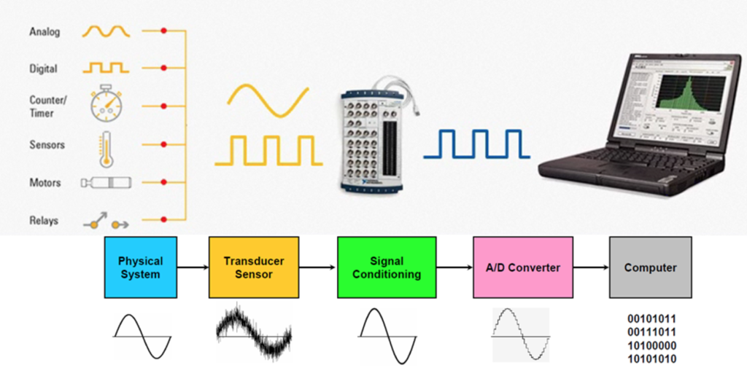

Figure 38 Schematic diagram of Data acquisition system

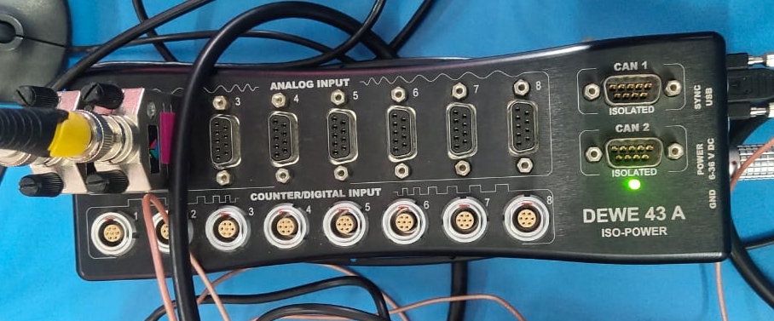

Figure 39 DEWE DAQ system

Connection In this 8 channel dewesoft FFT module we are connecting the accelerometer on channel 1 that will acquire the analog signals from sensor and further processing is done in dewesoftX software. This software will give us the acceleration plot and FFT plot in the axis of motion or movement.

Dewesoft is the leading provider of high-end data acquisition systems (DAQ). It’s applications are data recording, vehicle testing, NHH, power and energy, vibrational analysis, structural dynamics, acoustic, monitoring.



Figure 40 accelerometer

Accelerometer Specifications

Frequency range = 20Hz – 10000Hz

Sensitivity @ 100Hz = 9.749 mV/g

Transverse sensitivity < 5%

There is magnet on the surface of the accelerometer, which help us in mounting of sensor on the metallic part of machine. On whichever axis we want the vibration analysis in that order we can place the accelerometer.

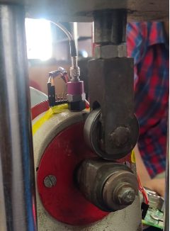

Figure 41 cam follower setup with accelerometer mounting

This is the cam follower setup we using to test the vibration. Motor is connected to cam shaft to give some input speed to the setup. Here we have tested the setup at two different speeds, so the force acting on follower will be different which will give more vibration in the vertical axis. At more speed the vibration amplitude is more and frequency at which peak is observed won’t change as the setup is not changed. This is the process we are following in the validation process.

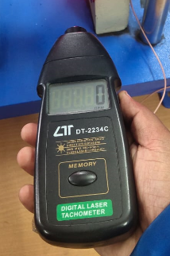

Figure 42 Digital laser Tachometer

A tachometer measures the rotational speed of a disk or shaft, such as a motor, and expresses results in revolutions per minute (RPM). Digital tachometers display readings on an easy-to-read LCD screen. Types of tachometer include analog, digital, contact and non-contact units. Some are handheld and use laser light and electronics to take readings from a distance; others are purely mechanical. Regardless of type, they all measure the rotation speed of machinery, such as motors and engines. This laser type digital tachometer is non-contact tachometer. The working principle of an electronic tachometer is quite simple. The ignition device triggers a voltage pulse on the output of the tachometer electromechanical component whenever the spark plugs fires. The electromechanical element responds to the common voltage of the series of pulses.

## Raspberry Pi setup

Accelerometer ADXL345 has its own installation program which is installed on raspberry pi.

Python language contains different libraries to run the different tasks. The necessary libraries also need to be installed on the raspberry pi card.

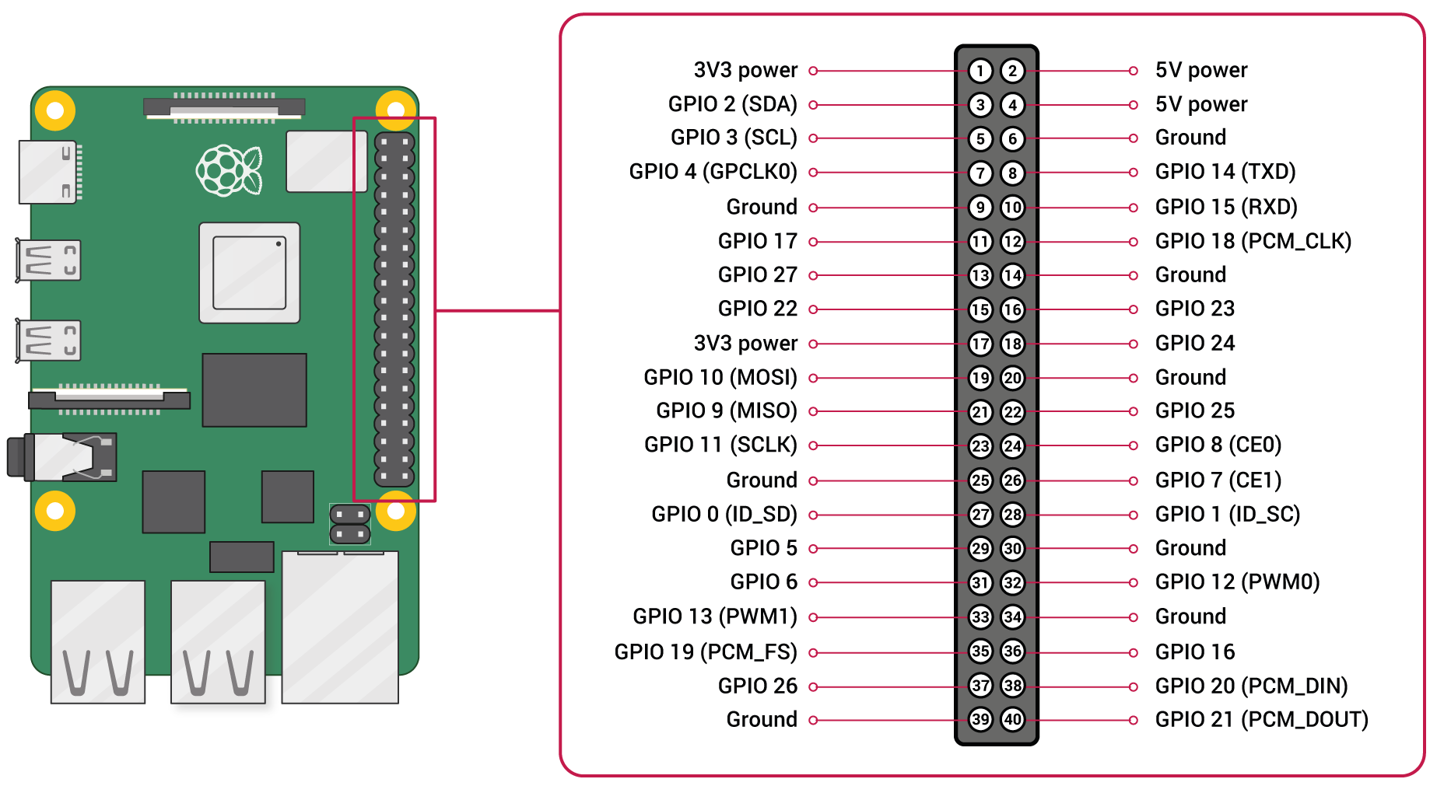

Figure 43 GPIO pinout diagram

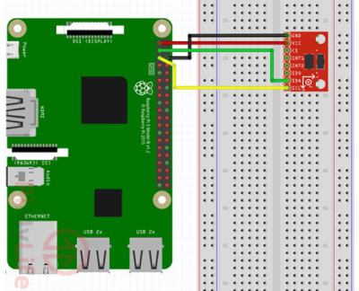

Figure 44 Connection of accelerometer ADXL345 with raspberry pi

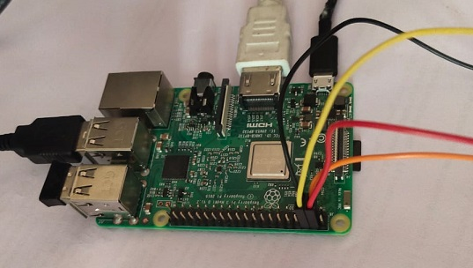

Figure 45 Raspberry pi after full connections

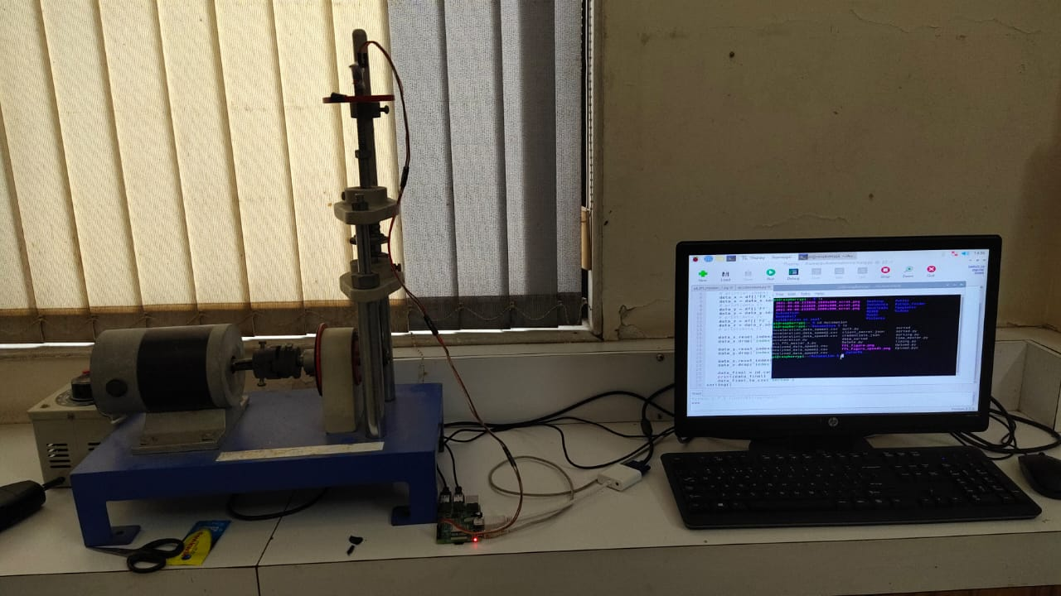

Figure 46 Full setup with connections

This is how raspberry pi connections looks like after connection with ADXL 345 sensor.

This is the complete setup, monitor is connected to pi with HDMI cable which gives the user interface for us, we can program code, view code, change the settings. Mouse and keyboard are connected to pi by USB port. Accelerometer ADXL 345 is connected to pi using jumper wires.

So far we have seen that using raspberry pi system we can perform condition monitoring on any machine system using a parameter monitoring like in these case we did it with vibration monitoring. Just like that we can monitor and analyze many parameters like acceleration data, gyroscope data, temperature data, current data, etc.

Depending on machinery under analysis we can monitor parameter accordingly. Also we can monitor different parameters of machine at a time or we can monitor different machines at same time. That multiple sensors scenario can be achieved using connection with breadboard.

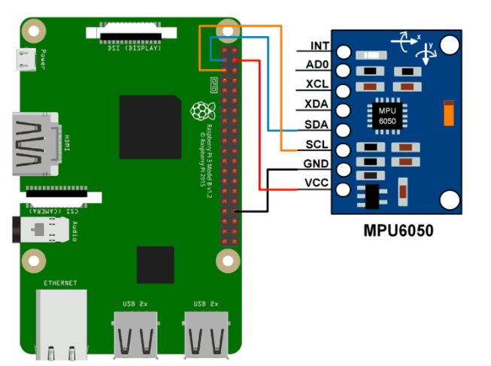

Figure 47 Wiring of MPU6050 with raspberry pi

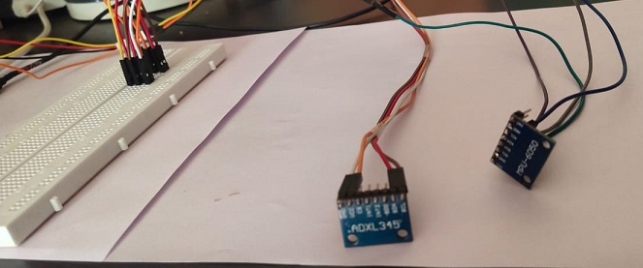

Figure 48 Breadboard with two sensors connected

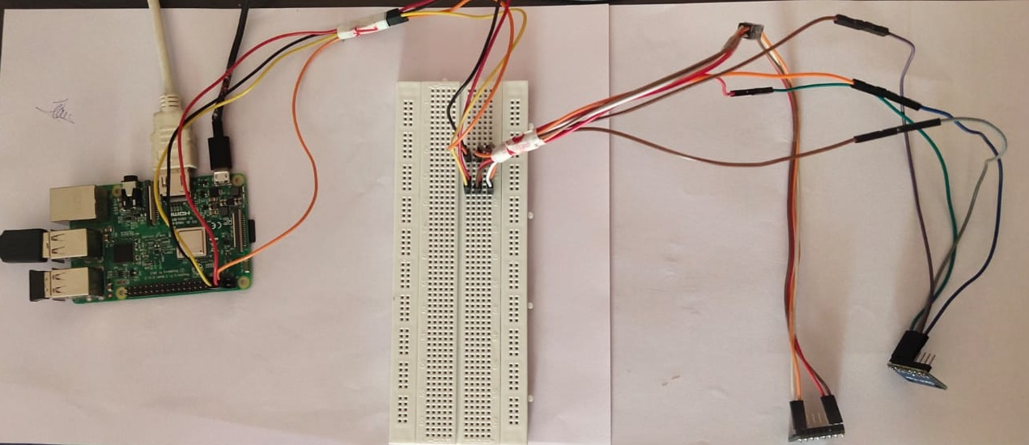

Figure 49 the whole connection with two sensors

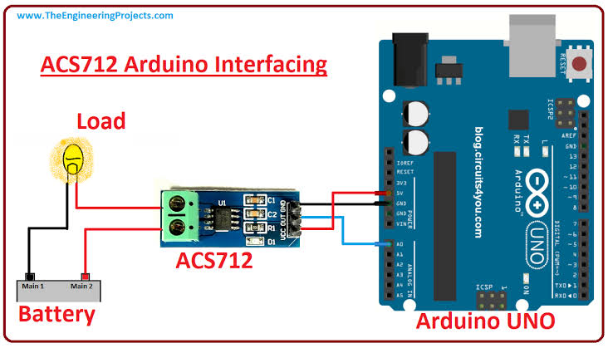

Figure 50 Wiring diagram of current sensor ACS712

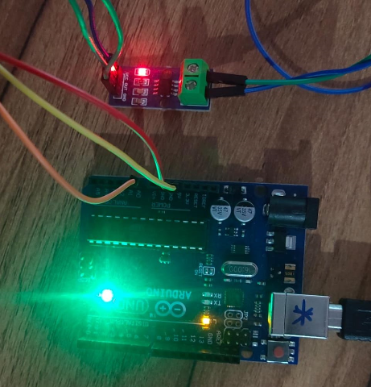

Figure 51 Wiring of ACS712 to Arduino Uno

# 8. RESULT & DISCUSSION

In series of code we run in order we get the results in order that order.

First we get the output of the extraction code, which gives the acceleration values in three axis with time. We get the code in tabular format and we save it in csv format. Output of code of data extraction is as follows.

|  |  |  |  |
| --- | --- | --- | --- |
| data from new session is written from here: | | | |
| Wed Dec 2 19:39:20 2020 | X | Y | Z |
| Wed Dec 2 19:39:20 2020 | 18 | -30 | 241 |
| Wed Dec 2 19:39:20 2020 | 20 | -31 | 242 |
| Wed Dec 2 19:39:20 2020 | 16 | -30 | 241 |
| Wed Dec 2 19:39:20 2020 | 17 | -30 | 243 |
| Wed Dec 2 19:39:20 2020 | 18 | -29 | 242 |
| Wed Dec 2 19:39:20 2020 | 16 | -26 | 245 |
| Wed Dec 2 19:39:20 2020 | 15 | -29 | 242 |
| Wed Dec 2 19:39:20 2020 | 24 | -23 | 242 |
| Wed Dec 2 19:39:21 2020 | 22 | -25 | 243 |
| Wed Dec 2 19:39:21 2020 | 22 | -21 | 243 |
| Wed Dec 2 19:39:21 2020 | 25 | -26 | 242 |
| Wed Dec 2 19:39:21 2020 | 27 | -24 | 247 |
| Wed Dec 2 19:39:21 2020 | 24 | -23 | 240 |
| Wed Dec 2 19:39:21 2020 | 27 | -25 | 241 |
| Wed Dec 2 19:39:21 2020 | 24 | -22 | 247 |
| Wed Dec 2 19:39:21 2020 | 25 | -23 | 243 |
| Wed Dec 2 19:39:21 2020 | 26 | -24 | 243 |

Table 1 Output of accelerometer data from sensor

1. Making a list of 2D array, first element time and second element amplitude of acceleration values in all the three directions.
2. Then, sorting it in descending order of second element that is amplitude

|  |  |  |  |  |  |  |
| --- | --- | --- | --- | --- | --- | --- |
|  | Time | X | Time | Y | Time | Z |
| 0 | Tue Jun 8 17:27:09 2021 | 470 | Tue Jun 8 17:27:09 2021 | 177 | Tue Jun 8 17:27:09 2021 | 511 |
| 1 | Tue Jun 8 17:27:09 2021 | 470 | Tue Jun 8 17:27:09 2021 | 177 | Tue Jun 8 17:27:10 2021 | 511 |
| 2 | Tue Jun 8 17:27:09 2021 | 226 | Tue Jun 8 17:27:10 2021 | 157 | Tue Jun 8 17:27:10 2021 | 511 |
| 3 | Tue Jun 8 17:27:09 2021 | 200 | Tue Jun 8 17:27:09 2021 | 149 | Tue Jun 8 17:27:10 2021 | 511 |
| 4 | Tue Jun 8 17:27:09 2021 | 200 | Tue Jun 8 17:27:09 2021 | 149 | Tue Jun 8 17:27:10 2021 | 511 |

Table 2 Acceleration peaks

The output shown in above table gives us the idea about the acceleration peaks occurred in the trial of the machinery. It gives the max acceleration values in trial in three axis and at what time they occur. So to keep track of change in vibration periodically to detect major change in vibration.

Sensor collect the acceleration data in time domain. For further analysis we also need the frequency domain data. So FFT comes in picture here. The time domain data is processed though the FFT code. From FFT code, we get the output as shown below.

|  |  |  |  |  |  |
| --- | --- | --- | --- | --- | --- |
| frequency of X | Amplitude of X | frequency of Y | Amplitude of Y | frequency of Z | Amplitude of Z |
| 0.00 | 53.03 | 0.00 | 47.50 | 0.00 | 476.37 |
| 0.34 | 3.07 | 0.34 | 2.04 | 0.34 | 7.24 |
| 0.69 | 6.62 | 0.69 | 0.76 | 0.69 | 8.76 |
| 1.03 | 4.48 | 1.03 | 1.23 | 1.03 | 7.43 |
| 1.38 | 3.55 | 1.38 | 0.89 | 1.38 | 9.82 |
| 1.72 | 2.42 | 1.72 | 2.40 | 1.72 | 10.37 |
| 2.07 | 1.26 | 2.07 | 1.63 | 2.07 | 7.61 |
| 2.41 | 1.52 | 2.41 | 0.27 | 2.41 | 7.27 |
| 2.76 | 2.13 | 2.76 | 0.72 | 2.76 | 5.36 |
| 3.10 | 2.05 | 3.10 | 2.03 | 3.10 | 10.13 |
| 3.45 | 3.05 | 3.45 | 1.05 | 3.45 | 7.96 |
| 3.79 | 0.76 | 3.79 | 2.87 | 3.79 | 13.76 |

Table 3 FFT values

From the above tabular data we get the frequency and amplitude of vibration trial, which tells us about vibration nature of the machine. From these data we also plot the graph of FFT nature.

As data visualization will give us the clear idea about the vibration nature than the data. So the plots look like the

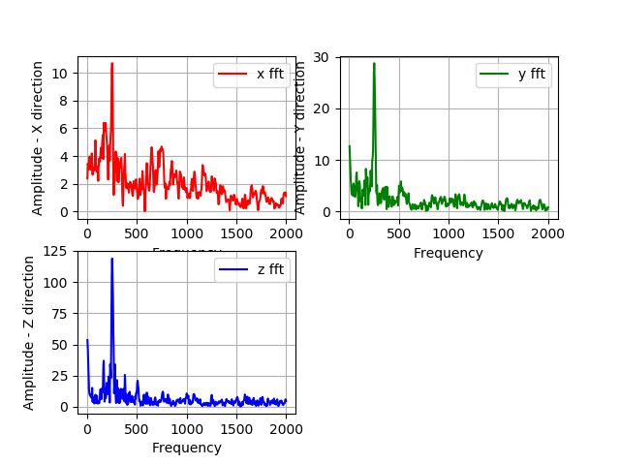

Figure 52 FFT plot sample

From the FFT data we got from the code, we find the peak amplitudes of the vibration and their corresponding frequency in x, y, z directions. Which tells us about the maximum amplitude is occurring at what frequency. So, by looking at periodic data we can detect any rise in amplitude of vibration at another frequency which tells us about presence of imbalance or fault present in machine.

|  |  |  |  |  |  |  |
| --- | --- | --- | --- | --- | --- | --- |
|  | FX | AX | FY | AY | FZ | AZ |
|  |  |  |  |  |  |  |
| 0 | 3.355705 | 47.55197 | 0 | 490.78 | 0 | 148.4267 |
|  |  |  |  |  |  |  |
| 1 | 127.5168 | 39.7611 | 127.5168 | 49.58895 | 127.5168 | 15.70128 |
|  |  |  |  |  |  |  |
| 2 | 130.8725 | 28.16092 | 130.8725 | 31.06386 | 3.355705 | 8.313788 |
|  |  |  |  |  |  |  |
| 3 | 6.711409 | 25.66657 | 124.1611 | 21.2913 | 130.8725 | 6.308352 |
|  |  |  |  |  |  |  |
| 4 | 124.1611 | 17.25682 | 120.8054 | 19.27833 | 120.8054 | 5.491521 |

Table 4 Peaks in FFT values

And finally. All the outputs we got from previous codes we upload on the google drive, so that data can be accessed later to review the history of the data. Also we get the all this data automatically from time to time, so that we don’t have to manually go to machine and take readings, this also reduce need of skilled person to do the job.

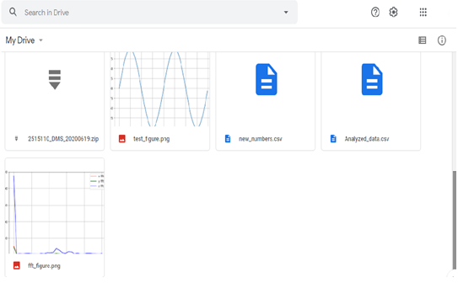

Figure 53 Snap of google drive after uploading the diagram

Similarly we have taken the gyroscope readings form sensor MPU6050, which also takes value from sensor, it gives the values from three axis and we collect the data in tabular format and save the data in csv format.

|  |  |  |  |
| --- | --- | --- | --- |
| data from new session is written from here: |  |  |  |
| Mon Jul 5 14:17:07 2021 | 0 | 0 | 0 |
| Mon Jul 5 14:17:07 2021 | -2.54198 | 2.396947 | 1.167939 |
| Mon Jul 5 14:17:07 2021 | -2.49618 | 2.526718 | 1.290076 |
| Mon Jul 5 14:17:07 2021 | -2.40458 | 2.381679 | 1.175573 |
| Mon Jul 5 14:17:07 2021 | -2.48855 | 2.442748 | 1.305344 |
| Mon Jul 5 14:17:07 2021 | -2.54962 | 2.458015 | 1.167939 |
| Mon Jul 5 14:17:08 2021 | -2.47328 | 2.473282 | 1.312977 |
| Mon Jul 5 14:17:08 2021 | -2.51145 | 2.374046 | 1.29771 |
| Mon Jul 5 14:17:08 2021 | -2.52672 | 2.396947 | 1.175573 |
| Mon Jul 5 14:17:08 2021 | -2.33588 | 2.419847 | 1.236641 |
| Mon Jul 5 14:17:08 2021 | -2.55725 | 2.572519 | 1.030534 |
| Mon Jul 5 14:17:08 2021 | -2.51145 | 2.450382 | 1.175573 |
| Mon Jul 5 14:17:08 2021 | -2.22137 | 2.465649 | 1.122137 |
| Mon Jul 5 14:17:08 2021 | -2.55725 | 2.473282 | 1.328244 |
| Mon Jul 5 14:17:08 2021 | -2.51145 | 2.51145 | 1.129771 |
| Mon Jul 5 14:17:09 2021 | -2.35878 | 2.641221 | 1.167939 |
| Mon Jul 5 14:17:09 2021 | -2.46565 | 2.374046 | 1.129771 |
| Mon Jul 5 14:17:09 2021 | -2.36641 | 2.419847 | 1.267176 |
| Mon Jul 5 14:17:09 2021 | -2.36641 | 2.366412 | 1.091603 |

Table 5 Gyroscope data

From collected gyroscope data we find the peaks in the data to see the variation in the peak value periodically.

|  |  |  |  |  |  |  |
| --- | --- | --- | --- | --- | --- | --- |
|  | Time | GX | Time | GY | Time | GZ |
| 0 | Mon Jul 5 14:17:07 2021 | 0 | Mon Jul 5 14:17:10 2021 | 2.755725 | Mon Jul 5 14:17:16 2021 | 1.473282 |
| 1 | Mon Jul 5 14:17:08 2021 | -2.22137 | Mon Jul 5 14:17:17 2021 | 2.671756 | Mon Jul 5 14:17:13 2021 | 1.442748 |
| 2 | Mon Jul 5 14:17:14 2021 | -2.31298 | Mon Jul 5 14:17:09 2021 | 2.641221 | Mon Jul 5 14:17:13 2021 | 1.419847 |
| 3 | Mon Jul 5 14:17:12 2021 | -2.32824 | Mon Jul 5 14:17:11 2021 | 2.633588 | Mon Jul 5 14:17:12 2021 | 1.374046 |
| 4 | Mon Jul 5 14:17:12 2021 | -2.33588 | Mon Jul 5 14:17:14 2021 | 2.618321 | Mon Jul 5 14:17:10 2021 | 1.374046 |

Table 6 Peaks in gyroscopic values

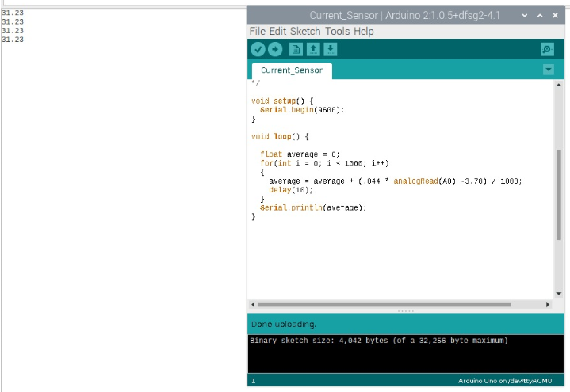

Figure 54 Output of Current sensor ACS 712 in Arduino IDE

This is how we get the output of current sensor ACS. On the left side we can see the program in the Arduino IDE, which will give the current output by reading the sensor value.   
And as shown on left side we will get the output displayed.

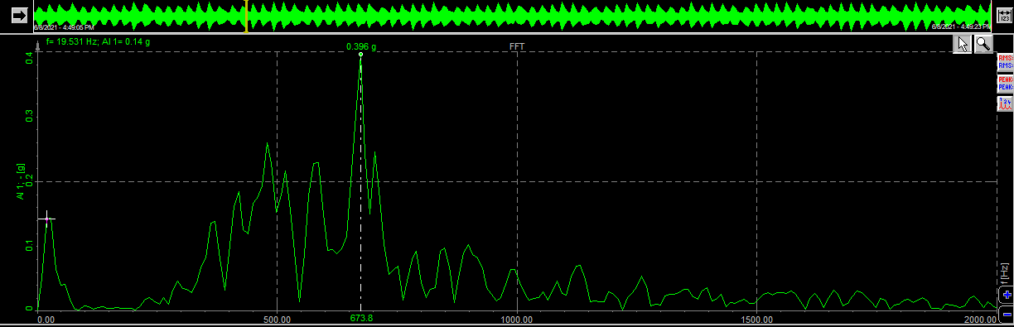

Figure 55 Dewsoft readings speed 1

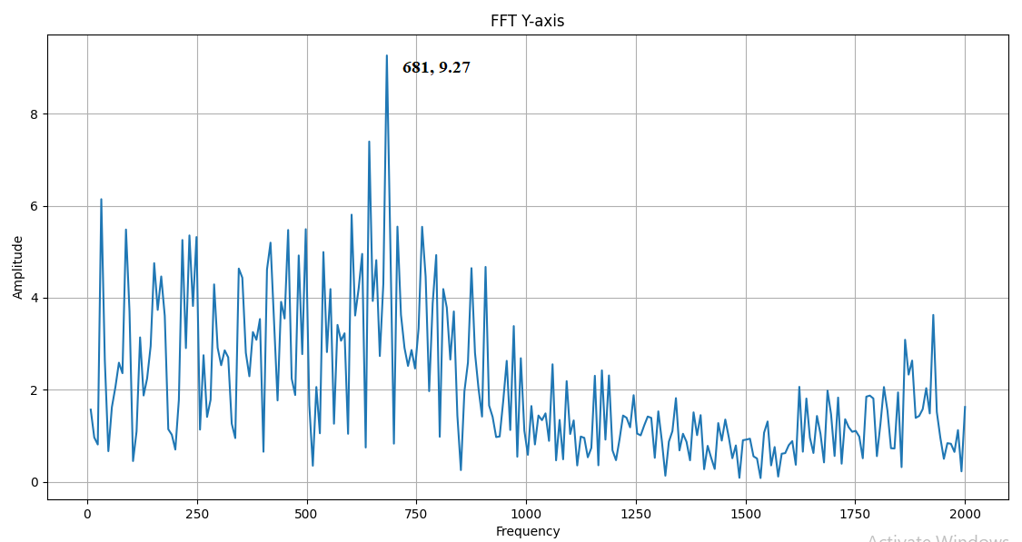

Figure 56 Pi readings speed 1

|  |  |  |  |
| --- | --- | --- | --- |
| Sr. No. | Reading | Dewesoft reading | Pi setup reading |
| 1 | Frequency | 673.8 | 681 |
| 2 | Amplitude | 0.396g = 3.88 m/s2 | 9.27 m/s2 |

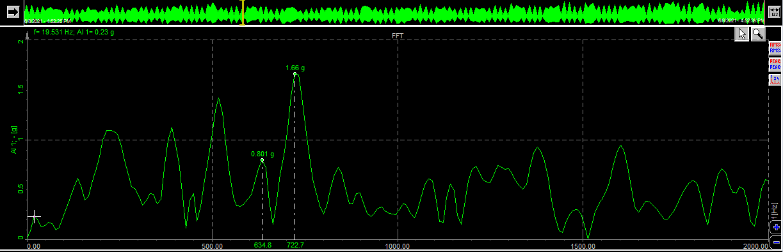

Figure 57 Dewsoft readings speed 2

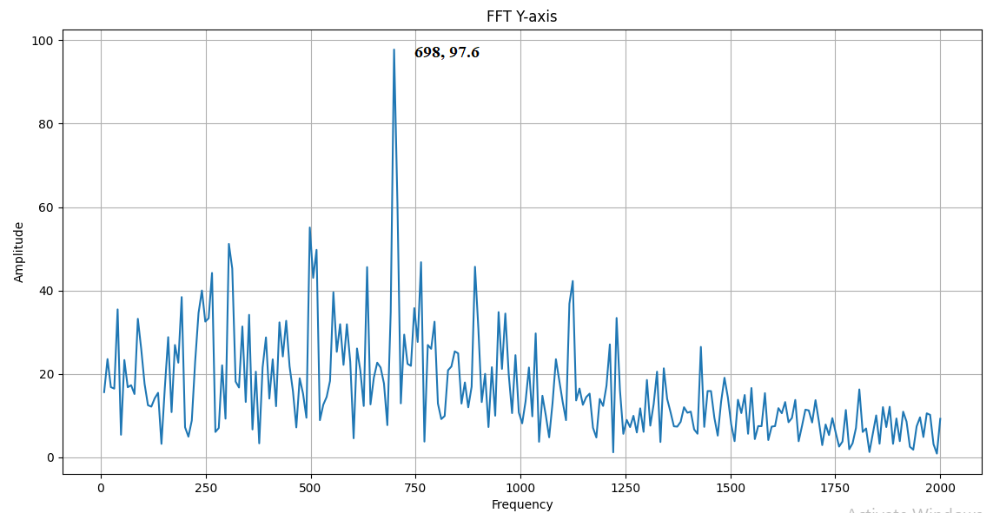

Figure 58 Pi readings speed 2

|  |  |  |  |
| --- | --- | --- | --- |
| Sr. No. | Reading | Dewesoft reading | Pi setup reading |
| 1 | Frequency | 722 | 698 |
| 2 | Amplitude | 1.66g = 16.28 m/s2 | 97.2 m/s2 |

The difference in the frequency is because we have placed both the accelerometer at small distance away. That placing or mounting error can be seen in the difference in the graphs. And secondly the main reason in the difference in frequency and amplitude values is the accuracy of the sensor. As the accuracy of sensor will play big role in finding the vibration of amplitude. Also, there is big difference cost wise also in two sensors. That results in huge difference in amplitude. But one part of the analysis where we succeed is finding the frequency where peak is present in FFT plot.

From this we can say that even with our accelerometer ADXL 345 values of amplitude will be in proportion. So, in proportion also we can check if there is change in nature of graph to predict the change in vibration nature of machine to predict the failure of the machine.

We also tried by adding a calibration factor to python program to achieve the same amplitude value. But at higher speeds we are still having the deviation in both the values. So as of now we are only focusing on the frequency of the peak amplitude for each trial.

We have used the kitchen appliance grinder mixer to check the setup. The mixer used is of Morphy Richards Company, where rotor rotates at 50Hz ~ 230V. Here we have taken the 3 readings/observation at 3 different speeds available in the mixer rotor. The output from this we expected is that as speed increases the frequency at which machine vibrates also increases. Ideally it should increase in exact multiples (2x, 3x). So, this test we will try to implement with our system to validate.

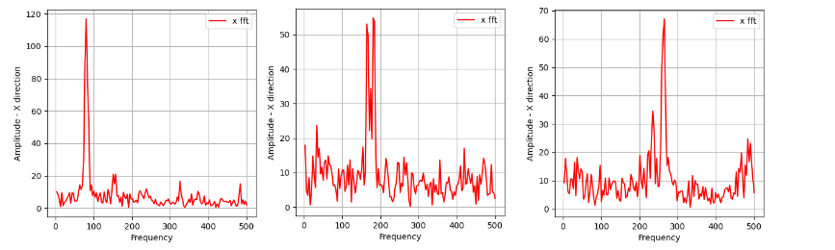

Figure 59 Variation in FFT plot with speed

Here we have the plots from three speeds in x-direction as x axis is the main vibration axis. The plot nature of the FFT at three different speeds is as shown in above figure. We can clearly see that the peak we are getting in the plots are shifting towards right side as the speed increase. This shifting should be in proportional to change in speed.

|  |  |  |
| --- | --- | --- |
| Sr. No | Speed | Frequency at peak |
| 1 | Speed 1 | 80 Hz |
| 2 | Speed 2 | 181 Hz |
| 3 | Speed 3 | 265 Hz |

From observation of FFT in x –direction at three different speeds. The peak in amplitude is observed near at 80 Hz at first grinding speed, peak at second speed is observed at 181 Hz and the peak at third speed is observed at 265 Hz. We can say that peak at second and third speeds are almost two times and three times than the peak at first speed.

# Conclusion

The hardware namely Raspberry pi microcomputer and Accelerometer ADXL 345 are installed.

The software need to run the project is Python programming language which is installed in the Raspberry pi microcomputer.

The necessary libraries for python codes along with ADXL345 installation program are installed in Raspberry pi microcomputer.

Python codes are developed for

1. Extracting time series data of machine from accelerometer
2. FFT analysis
3. Detection of peaks in the data
4. Uploading the data to the server
5. For automation of codes to regularly implement after time interval.
6. Getting gyroscope data from gyroscope sensor.
7. Extracting current values from current sensor.

The python codes are tested and are working. The raspberry setup is ready to use on real machines. From the trials we were able to predict the frequency, but there is big difficulty in perfectly finding amplitude. As the accuracy of sensor will play big role in finding the vibration of amplitude. That results in huge difference in amplitude. But one part of the analysis where we succeed is finding the frequency where peak is present in FFT plot.

From this we can say that even with our accelerometer ADXL 345 values of amplitude will be in proportion. So, in proportion also we can check if there is change in nature of graph to predict the change in vibration nature of machine to predict the failure of the machine.

So, final output from this raspberry setup is pi is able to take the acceleration values after regular interval and then pi processor performs the FFT analysis and then from FFT values, top amplitudes and their corresponding frequencies can be found out and FFT plots can also be plotted and saved in Pi memory. Then they are uploaded to google drive. From their google drive maintenance team can see the FFT values and plots to check if any change in vibration nature. So to take further actions accordingly. This overall operation is possible with help of our system. Along with other sensors can also be connected to our system, with which we can use to monitor other parameters of machine like gyroscope, temperature etc. or from same pi we can monitor many machines.

# 10 Future Work

* + 1. Testing is to be done on machines and calibrate the system. So, we can use our system on different setup for condition monitoring. From this setup we are able to predict the frequency where peaks are in vibration. Main concern is predicting the amplitude of peak. For the further analysis. For this we can try this with accelerometer with good accuracy.
    2. The accelerometer is of the size of the sim card, flat and rectangular. We need to find a way better way to place the acceleration sensor on the metal of the machine. Currently we are using cello tape to mount the sensor on machine.
    3. We can also use the machine algorithm to predict the fault in advance by training the machine learning model to predict the change in fault in the machine due to vibration. As per our project we are able to upload the data enough to predict the fault by looking at it. But with machine learning, we can directly send the message or document saying that the vibration is abnormal or normal. So, no skilled manpower dependency is required to read the data.

# 11 REFERENCES

1. Development of Vibration Spectrum Analyzer Using the Raspberry Pi

By Marek Iwaniec, Andriy Holovatyy, Vasyl Teslyuk, Mykhaylo Lobur, Kostyantyn Kolesnyk, Marta Mashevska

1. Recent Progress on Mechanical Condition Monitoring and Fault diagnosis By Chenxing Shenga, Zhixiong Lia, Li Qinb, Zhiwei Guoa, Yuelei Zhanga
2. Centrifugal Pump Condition Monitoring and Diagnosis Using Frequency Domain Analysis

By Maamar Ali Saud ALTobi1 (&), Geraint Bevan2, Peter Wallace2, David Harrison2, and K. P. Ramachandran

1. Condition Monitoring of Deep Groove Ball Bearing using FFT Analyzer By Vikram Talekar1, Prof. L. S. Dhamande2
2. The monitoring system of an actual technical condition for pumping units with frequency analysis

By Saubanov Oscar*, Valeev Anvar

1. Real Time Machine Health Monitoring and Vibrational Analysis using FFT Approach

By Himanshu K. Patel, Dhagash Shah, Avani Raghuwanshi

1. Fault diagnosis system of rotating machinery vibration signal By Lei Youa, Jun Huc, Fang Fanga, Lintao Duanb
2. Online Condition Monitoring of Induction Motors through Signal Processing By S. H. Chetwani, M. K. Shah & M. Ramamoorty
3. Fast Fourier Transform and a Complimentary Filter Based Control of a Robotic

System:

By Agon Kokaj. Ines Bula. Artan Dermaku

1. Gear Fault Detection Using Vibration Analysis and Continuous Wavelet Transform

By K. Vernekar, H. Kumar, and K. V. Gangadharan

1. Multiple-Fault Detection Methodology Based on Vibration and Current Analysis Applied to Bearings in Induction Motors and Gearboxes on the Kinematic Chain

By J. J. Saucedo-Dorantes, M. Delgado-Prieto, J. A. Ortega-Redondo, R. A. Osornio-Rios, and R. D. J. Romero-Troncoso

1. Vibration condition monitoring of planetary gearbox under varying external load

By W.Bartelmus, R.Zimroz

1. The Vibration Monitoring Methods and Signal Processing Techniques for Structural Health Monitoring: A Review

By D. Goyal, B. S. Pabla